4.2 Valuing quality information

(1) Concept of product quality

1) Three qualities
As mentioned in Section 1.1, there are various discussions regarding product quality. One is that the content of quality changes depending on the position. Three types of quality can be considered: quality required by the market and customers, quality aimed at by design, and quality with little variation created by manufacturing. ``Quality demanded by customers and the market'' is expressed in words such as ``delicious food'' and ``good-driving cars.'' The ``words'' of words translate into ``things,'' and what is written in catalogs such as ``maximum acceleration〇〇km/s²'' is the ``quality aimed at by design.'' ``Quality of workmanship'' is the embodiment of the quality that the design aims for in the form of ``products.'' Process control is performed, and quality with good processing and assembly accuracy and little variation is required. It is transformed from a verbal "thing" to an actual concept, and then to a "thing."

2) Safety and quality
Safety has slightly different meanings depending on the word that comes before it, such as product safety, food safety, nuclear safety, traffic safety, and occupational safety. For example, the definition of ``food safety'' in the Codex Alimentarius Commission's ``Recommended International Code of Practice—General Principles of Food Hygiene, FAO, 2003'' is ``Assurance that food will not cause harm to the consumer when it is prepared and/or eaten according to its intended use,'' which gives confidence that no harm will occur based on the ``intended use.'' Product safety for automobiles and other products stipulates that they must be designed to protect occupants not only during ``intended use,'' but also in ``reasonably foreseeable forms of use'' such as collisions. Furthermore, recent advances have been made in the development and practical application of active safety technology that detects and avoids collisions.

3) Product quality structure
It goes without saying that the most important thing is to provide safety and give a sense of security, as is typically seen in food, which is a "thing". On the other hand, as ``goods'' become more abundant and consumers have greater freedom of choice, it can be said that the discussion of safety and security only comes up when the premise that ``this food is delicious'' is satisfied. The range of usefulness equivalent to ``delicious'' has expanded to the reliability of ``little change in taste over time'', and the safety of ``not containing harmful substances and not being produced within the expiry date'' must also be satisfied. Furthermore, the content of ``delicious'' can be further divided into functional aspects related to calories and nutrition, and psychological characteristics such as ``refreshing'' and ``good texture.''
However, if we focus on the product life cycle from development to production, use, and disposal, it is important to minimize the impact not only on the people using the product but also on the environment. Electronic control devices are also used in many products, and solder is used as a brazing material for these circuit boards. Hazardous materials contained in solder pose a problem during disposal. From this perspective, efforts have been made to develop and adopt lead-free solder, contributing to reducing environmental impact. RoHS (Restriction of the use of certain Hazardous Substances in electrical and electronic This directive restricts the use of six substance groups: lead, mercury, cadmium, hexavalent chromium, PBB (polybrominated biphenyls), and PBDEs (polybrominated diphenyl ethers) in electrical and electronic products marketed within the EU after July 1, 2006.

(2) Add value to information in new product development

1) Integration of activities that affect product quality
The word quality is used not only for products and services, but also for operations and management, such as design quality and manufacturing quality. New product development consists of the activities necessary to turn ``things'' such as required quality into ``things'' (products).
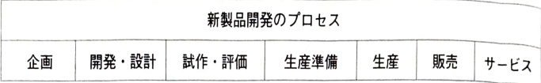
Figure 4.2.1 Concept of steps in the new product development process
As shown in Figure 4.2.1, it is the ``flow of activities'' that is the sum total of activities that create new customer value by transcribing information from customers and the market and embodying it as ``things''. The quality aimed at by design and the quality with little variation produced by manufacturing can be said to be the output and solution of activities at the functional level of design and manufacturing, respectively. New product development, which converts customer and market quality requirements into solutions such as specifications and drawing information, involves a variety of activities such as planning, design, and production preparation, and product quality is affected by the degree to which these are integrated.

2) Valuing information in activities and product quality
The smallest unit in new product development work is the activity of each individual, and what is generated and passed on is information, and the ``information flow'' is the lifeblood. As shown in Figure 4.2.2, each activity can be expressed as a process model whose core is ``information valorization,'' which converts input information using knowledge, skills, etc., and outputs solutions (problem solving).
The solution that is the output of an activity may contain not only information that is essential for subsequent activities, but also information that has unnecessary negative value, equivalent to a nonconforming product. Problems such as drawing tolerances that are difficult to create with current production and manufacturing technology and inappropriate material instructions manifest themselves as quality problems in production and the market due to drawings. We will review the business process for new product development so that we can detect such quality problems early and take measures such as design changes to prevent them from leaking. In the past, a single set of tasks that were handled by oneself in the workplace environment has now been subdivided and specialized, creating gaps in the tasks, which may be a factor in the leakage of problems. Problems that must be discovered during structural studies and design calculations
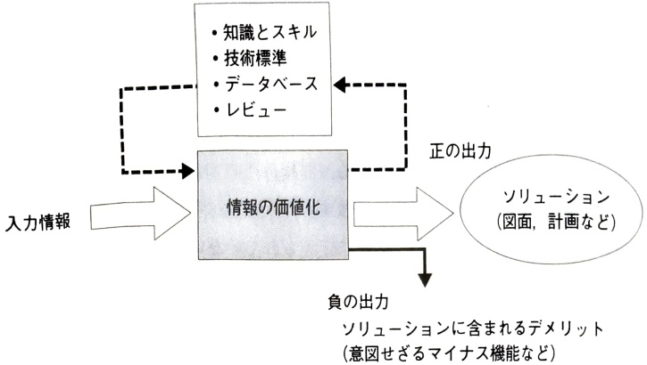
Figure 4.2.2 Activity process model and valorization of information
The increasing sophistication and evolution of digital technologies such as CAE have led to their becoming more specialized, creating situations in which designers are unable to make discoveries on their own. This suggests that it is necessary to use simple CAE that designers can use themselves.
Business improvement involves understanding the current status of quality, cost, and time, arranging management resources such as people and technology to achieve these goals, and reviewing the design of activities and knowledge itself. The mission of design is to reduce the number of design revisions and to guarantee the output to subsequent processes, which is the performance of business quality.

3) Business processes and organizational structure
Christensen [4] defines organizational learning as the continuation and improvement of business processes. The manufacturing process of processing and assembly is easy to visualize because it mainly involves the "flow of goods" and involves tangible objects. Of the 4M conditions of manufacturing: Man, Machine, Method, and Material, as automation progresses, the importance of equipment (Machine) will increase. The flow of goods and productivity change greatly depending on equipment setup, layout, etc. Efforts are being made to optimize and standardize setup procedures, and provide education and training to help people follow these procedures. In other words, it is necessary for work.
If you clearly define the necessary management resources, it will be easier to proceed with maintenance and management in an organized manner.
On the other hand, the work of indirect departments such as the head office is mainly concerned with the flow of information. Information is intangible and difficult to see directly, from where to where it flows and where it stops. As information technology evolves, the flow of information that was open and visible to the outside world when using paper media has become less visible. The 4Ms in indirect departments may be considered to be knowledge-based operations compared to manufacturing processes in which tangible goods flow, but they are often not clearly defined. In order to utilize information technology to achieve both efficiency and effectiveness in business operations, it is necessary to standardize processes.

4.3 Source management and comprehensive management in new product development

(1) Source management and comprehensive management

1) How to proceed with source management
Let's think about process improvement/innovation that utilizes KPIs in the new product development process.
In order to utilize the KPI of design changes for improvement, it is not enough to simply look at the number of design changes. This does not mean that fewer design changes are better. If you are not aware of the need for design changes, design problems may leak out and problems such as recalls may occur in the market. It is difficult to avoid mistakes when working on something unknown, such as development, and if you view changes too much as a problem, it will affect your motivation to come up with new ideas and take on new initiatives.
The timing of changes is more important than the number of design changes. The cost and impact of changes vary depending on timing. The "principle of design changes" is to discover problems early and make necessary changes quickly. Therefore, as a direction for improving the way design changes should be made,
・Design changes due to early emergence of design quality issues
·Prevention of design quality problems

Consider the following order. This is a way of thinking that emphasizes the value of discovering problems as early as possible, and encourages people to discover and prevent problems themselves, even if they are built-in.
To this end, as shown in Figure 4.3.1, it is a good idea to grasp the ``chronological information on design changes'' regarding the progress of the development process and design changes, and to clarify the status of occurrence and resolution of quality problems caused by the design after production has started. When working on something unknown, such as new product development, there are always things you won't know until you try. Avoiding problems after the fact,
・Technology risks in commercializing unprecedented technology
・Concept risk in developing products with unprecedented concepts
・Market risk in product development targeting an unprecedented market
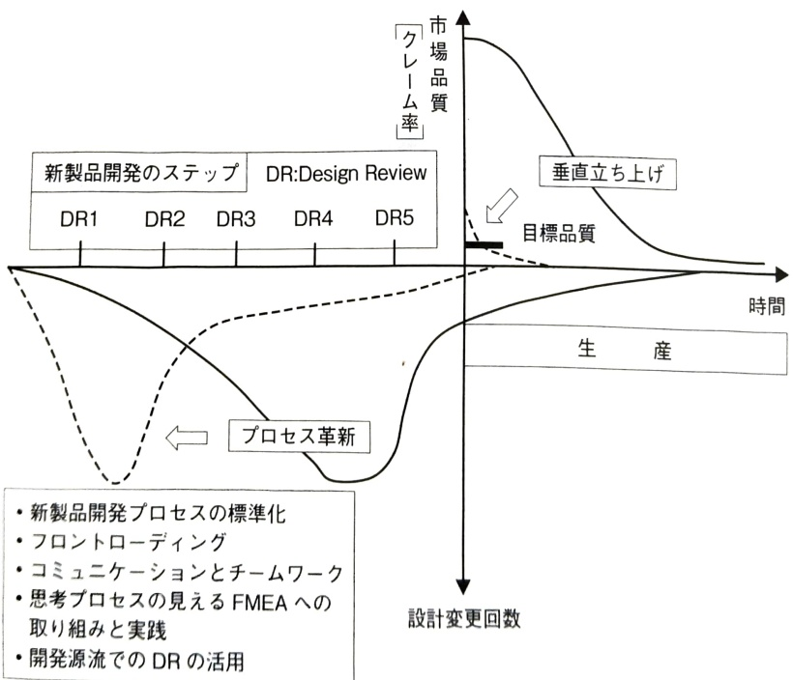
Figure 4.3.1 Vertical launch through innovation of new product development process

people stop taking risks, and there is a risk of opportunity loss due to delays in adapting to technological advances.
The most important thing when making design changes during new product development is to ensure that problems can be discovered and resolved early so that they do not become latent. This changes depending on the potential of the group such as communication style, the potential of individuals such as competency, and the effectiveness of the system and operation as an organization such as design review to complement each designer.
Problems associated with wasteful design changes include insufficient collection of information on usage/environmental conditions and customer requirements, insufficient time for design changes resulting in unreliable responses, and poor review functions that prevent problems from becoming latent and leaking to subsequent processes. If problems are discovered early in the new product development process and fundamental countermeasures are taken, quality problems will be less likely to occur once mass production begins.
Generally speaking, design changes at the source of development are essential. However, design changes in the late stages of development will be reduced as much as possible through process improvements and innovations, as shown in Figure 4.3.1. Identify issues that were not discovered in the early stages of development, provide the management resources necessary to solve them, and manage the process based on the results. We will improve ``management resources and business processes'' so that problems can emerge early, and respond based on values ​​that complement the bounded rationality of individual designers as an organization. In addition, rather than relying solely on KPI indicators, we will strive to detect and resolve problems early through communication with the field, promote initial flow management to reduce quality problems after mass production, and enable vertical startup.

2) Integrated problem solving that incorporates the idea of ​​“complementarity”
As shown in Figure 4.2.2, business can be modeled as a value creation process that converts input into value and outputs it. What flows is information and things. Since things are tangible objects, they are easier to visualize than information about intangible objects. quality and form between input and output
The meaning of ``added value,'' which is a change, is also easy to understand. Compared to physical objects, the flow of information cannot be directly observed. The media used for transport are diverse, from the five senses to paper to electronic media, and each has its own characteristics. Although electronic media can convey information to many people at once, its ability to convey information is considerably lower than that of face-to-face media that utilizes the five senses, and it often takes time to share information.
The flow of information in new product development has a hierarchical structure, as shown in Figure 4.3.2, from the activity level of the development department's ``Design of △△ units,'' to the functional level of ``Design of XX product,'' and to the functional cross-organizational level of ``Planning, design, and production of XX product.'' Top-down from function to activity level
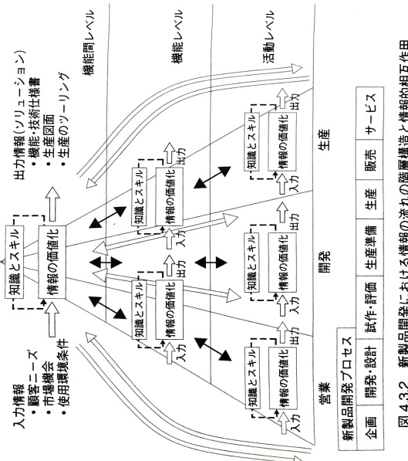
There is also a flow from the bottom up through feedback from the activity level to the functional level. It is a bidirectional, non-linear flow of information, and it improves the flow of information so that the coordination functions of the people involved work.
It is not realistic to understand and control each and every complex flow of information. In order to share and share information, it is important to clarify the interface between transactional tasks and to create a work environment that allows for sharing of space. If all members of the development team gather in a large room and create an environment where tests and evaluations can be conducted in the same place, communication using the five senses will inevitably be activated, and the effect will be great.
It is also important to devise ways to ensure that engineers with high pride do not have to deal with failures alone. Some companies have monthly meetings where the development leader reports on the current situation in front of all executives, including the president, once every six months, and where the technology planning department and others are available to listen to what is being said. If there is an issue that is not going well, the Technology Planning Department will immediately instruct others within the company to provide support, making the progress visible to those around them. If the person in charge hits a wall, don't miss the moment to ``throw in the towel.'' By taking the next step early, we can correct our development goals and lend a helping hand as an organization.

② Comprehensive management of Q (Quality), C (Cost) and T (Time)
The KPIs used to evaluate the performance of whether new product development information is shared and shared and are linked to value creation are quality, cost, and time, similar to the three elements in production. Each of these elements has the following characteristics.
Regarding quality at the new product development stage, there are three meanings of quality:
· Required quality
·Design quality
· Manufacturing quality

There is. Furthermore, the market quality at the stage of supply to the market is followed up and reconciled with the three quality evaluations at the development stage, and feedback is provided to the next generation of new product development.

Regarding cost.
・Allowable cost
・Target cost
・Actual cost
and is transformed. In other words. Calculation of allowable costs based on the expected sales price and medium-term management plan. Consideration for workability and assemblability. Estimating target costs based on product design and production line design and adjusting allowable costs using VA/VE, etc. It is necessary to successively create target costs through cost evaluation at the design stage and place emphasis on managing actual costs.
As for time, using the backward concept, starting from the start of production of the new product being developed, as shown in Figure 4.3.3,
Concept $ \left(-t_{6}\right)\rightarrow $Concept design $ \left(-t_{5}\right)\rightarrow $Detailed design $ \left(-t_{3}\right)\rightarrow $Prototype/evaluation $ \left(-t_{2}\right)\rightarrow $Production standard
Preparation $ (-t_{1})\rightarrow $Sales $ (0)\rightarrow $Sales
Set milestones for development steps and use them as key points for progress management.
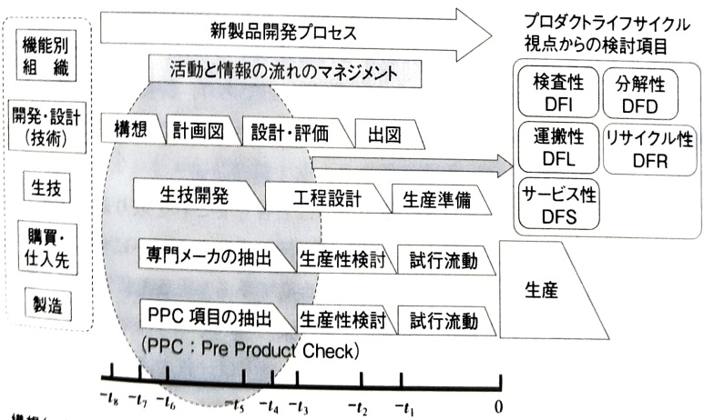
Concept $ \left(-t_{6}\right)\rightarrow $Concept design $ \left(-t_{5}\right)\rightarrow $Detailed design $ \left(-t_{3}\right)\rightarrow $Prototype/evaluation $ \left(-t_{2}\right)\rightarrow $Production preparation $ \left(-t_{1}\right)\rightarrow $Production(0)→Sales
Figure 4.3.3 Concept of new product development milestones and backward scheduling
The keyword for simultaneously achieving these QCT KPI goals is the concept of complementarity. If we look at the activity level of "〇〇design," QCT is integrated. Drawings determine most of the quality and cost of products and services provided to customers, and control development lead time. QCT includes:
・If the quality of activities that convert information into value improves, the speed will also increase.
・If the speed is faster, development costs can be reduced, and the scope of consideration can be expanded, reducing the number of parts and providing solutions with good processability, which can reduce manufacturing costs.
・If you can discover and verify a solution that achieves your quality and cost goals, you can achieve your time goals.
There is a complementarity, and it can be used for integrated problem-solving management of QCT.The activities of thought process design up to the release of drawings are divided into two: analysis and drawing creation.If a design problem surfaces at the drawing or prototype confirmation stage, it will lead to undesirable results in terms of both cost and time.If it is possible to adopt modeling and simulation methods that grasp the key points from prototype evaluation using physical objects, it will be possible to repeat design and evaluation in a short time, The speed of development becomes faster and the ability to develop new products to respond to market changes becomes faster.To simultaneously achieve cost and time goals, an effective method is to improve the quality of modeling and simulation, including analysis, and FMEA is performed to extract evaluation items and adjust evaluation/confirmation methods to verify their validity.
Improving the quality of analysis involves careful work that focuses on and eliminates the negative outputs of the process. If the amount of water is small, it is easy to remove dirt and clean it, or to throw away the dirty water and start over from scratch. However, there are significant restrictions on reviewing the equipment at the stage of arranging equipment and manufacturing molds. The concept of ``the output of the process is the solution'', which is explained in detail in Section 3.5, means that the negative output is below an acceptable level, and an acceptable level means that even after-the-fact responses are acceptable.


(2) Commitment of the production department in new product development

1) Organizational utilization of the “power of post-processing”
Based on the "push-to-pull" concept, the production department actively commits to new product development from the early stages of development, and leverages the power of back-end processes to achieve overall optimization. In order to establish methods and processes that can stably manufacture products that meet design specifications at target costs within an appropriate development lead time, and to lead to a vertical ramp-up of production, the production department must actively participate and commit from the development stage and promote information sharing, as shown in Table 4.3.1.
What is the necessity and significance of participation in the production department at the development stage? It can be organized as follows.
・Design considerations for effective use of new materials
• Design consideration for adopting new processing technology and effective use of existing equipment (e.g., switching from thread cutting to thread rolling to eliminate burrs and consideration for chamfer angles, etc.)
- Introducing flexible large-scale production lines and processing equipment that can be shared by many models, and design consideration to achieve results (e.g., flowing lines through connections, line formation, optimization of in-process logistics systems, etc.)
• Improving productivity by using jigs and tools for setup and adjustment, making inspection and inspection easier, etc.
・Design considerations to increase the production efficiency of processing robots
・Design considerations for inspection equipment, etc. in response to the increasing number of electronic devices installed
・Design considerations to significantly improve manufacturing quality
・Design considerations to significantly reduce manufacturing costs (e.g. structure with fewer grinding points)

2) Visual management from the beginning stages of development
The more people can see the problem, the less potential problems will become latent. By linking with 3D CAD and analyzing using 3D simulation software for processing and assembly, the knowledge of the production department will be incorporated into product development from the early stages of development.
Utilizing DA (Digital Analysis) to check placement interference, workability, quality assurance, etc.
・Preliminary verification engineering
Table 4.3.1 Development steps and production department commitment
development steps | Activities and information flow | Content
plan | Production concept development | From the initial stage of development, develop the requests of the production department that should be incorporated into the product development concept, summarize the requests of the sales and production departments, and carry out development planning (design department)
Design/Prototype | Design/Prototype | The QA table complements drawings, technical specifications, and parts lists, and conveys requests and production precautions from the design department to the production department.
Drawings, technical specifications, parts list, QA table | Consider the balance between quality, cost, and productivity, and consider basic matters (techniques for creating a flow) in order to determine and design requests for construction methods (techniques for making things) and production equipment, and incorporate them into the production process.
Construction method development | Identify production bottleneck technologies and promote resolution before mass production (Past process quality information is brought to light through QA matrix, latent failure modes are brought to light through process FMEA, etc., and utilized for recurrence and prevention)
FMEA of process | Develop equipment specifications that meet design and production requirements, prepare not only equipment but also jigs and tools (all tooling) before starting production prototypes, and evaluate prototypes using mass production methods.
Important process analysis table | Design a flexible process that takes into account cycle time, setup, adjustments, etc. to ensure smooth production.
equipment planning | Based on improvement plans based on reviews of market quality issues such as complaints and in-house defects, we formulate a 4M condition management method.In particular, in the automation process, we develop a Q component that compares the key points of production equipment management)
process design | Determine production and inspection control items and methods in order of process
Standard work combination sheet | Create standards to be used on-site and practice KM decisions
Process control plan | QC process chart
Work standards | Inspection standards
Production execution | production
・Thorough verification during the development phase
Thorough creation on one screen
Examining the feasibility of one process
Required quality for production
·Slim/Simple/Speed/Clear etc.
·Commonization and reduction of parts types
・Drawing data that can be used overseas
・Promote simultaneous global vertical launch through simultaneous communication with overseas.
Assembly line quality near misses.
・Problems with human movement
・Jig problems
・Parts box problem
・Problems with tools and cutters
・Equipment problems
・Line/work area issues
It can be classified as follows. Examples of human movement problems include:
・Assembling: It is easy to confuse front and back, right and left / It is easy to make a mistake in the assembly order / It is easy to forget to assemble
・Tightening: Over-tightening/Not-tightening enough, screws coming loose/Difficult to tighten and easy to fail/Forgetting to tighten
・Insertion: Insert diagonally/inserting a foreign item/forgetting to insert it
・Application: Applying too much grease (adhesive), etc./Insufficient amount of grease, etc., not uniform/Forgetting to apply grease, etc.
・Wiring: Too much tension and easy to remove/Poor soldering/Forgotten solder/Wrong wiring
・Storage: Holding/touching areas that should not be touched/rough handling resulting in external scratches, dents/dropping
・Inspection: Misreading of needles and letters (hard to see)/Dial setting position error/Inspection
(measurement) forgotten
There is.
The production line and product performance are reproduced on a computer, and the on-site situation is examined using 3D display software, checklists, and guidelines. Integrating various knowledge through DfX† (Design for "X") is essential to shortening development lead time and smoothing production start-up.

3) Equipment and process design aimed at optimizing the whole from the parts
We will advance overall optimization not only from a technical perspective, but also by expanding the scope of our thinking, including eliminating processes that do not produce added value, reducing costs including maintenance, and flexibly responding to changes in demand.

① Process design with consideration to the site, including setup/adjustment, equipment management, etc.
Proceed with setting high goals by taking on challenges beyond the ordinary/unconventional. In die casting molding, it is common knowledge to increase the injection pressure to reduce the processing time by half, but simply increasing the injection pressure does not lead to speeding up. By lowering the injection pressure, the size of the mold and machine can also be reduced, resulting in a 50% reduction in capital investment. The following items are easy to overlook during digital engineering verification:
- Simplification of transportation: If you change from "jigs + product transportation" to only product transportation, the number of jigs will be reduced to one, making setup and adjustment easier, and improving the ability to handle mixed flow production.
・Equipment generalization: Moving away from specialized equipment and jigs through robotization is an important approach to generalization.
is also important.

② Flow optimization using bird's-eye view ability
Look at the entire process and work flow from a bird's-eye view, discover and resolve losses and waste, and proceed with improvements. For example, in order to focus on the dependencies between processes and advance overall optimization, one must thoroughly understand the characteristics of the construction method and design a process that "optimizes the flow." Table 4.3.2 shows the dependence on the previous process in the internal polishing method. For internal polishing, reaming has a high cutting ability, but honing has a low cutting ability and is highly dependent on the previous process. Ken
Table 4.3.2 Dependency on previous processes in internal polishing method
Inner surface polishing method | principle | Method | ability to sharpen | Dependency on previous process (inner surface processing) (surface roughness, coaxiality, etc.)
Turning (reaming) | sharpen | Cutting is performed at the biting part of the cutting edge, and burnishing is performed at the margin (outer periphery of the blade). | shell reamer | Great cutting ability | little dependence
Grinding (internal grinder) | sharpen | The cutting edge of many abrasive grains on the surface layer of the grindstone work surface scrapes the surface of the workpiece into many fine chips. | Grinding while holding the workpiece | Craft shoe | Ability to sharpen | medium dependence
Abrasive processing (honing processing) | sharpen | A contact force from a spring or hydraulic pressure is applied to several rectangular bar-shaped trickle grindstones that are in surface contact with the inner surface of the cylinder, causing them to reciprocate in the axial direction while rotating. | Coaxial side | ∩ Small scraping ability | ∪∪ Highly dependent
Table 4.3.3 Standard work combination sheet
Standard work combination sheet
In accordance with the quality standards for surface roughness that must be guaranteed in the polishing process, we will proceed with process design that takes into account the combination of polishing methods and cost.
The cycle time of a unit process can be clarified using the standard work combination chart shown in Table 4.3.3. By focusing on bottleneck processes with long cycle times and streamlining them, throughput will improve, contributing to productivity and quality improvements.

4) Quality assurance activities involving partner companies
Guaranteeing each individual part requires a quality chain management system that includes partner companies. To avoid falling into the trap of a quality black box, we can make it visible and promote quality control activities by involving partner companies. Steady and continuous improvement of the QA network is necessary.
In a QA network, pay attention to the following quality black boxes:
It is necessary to
・Poor quality of procured parts is one of the most common causes of malfunctions in digital home appliances and information devices, along with defective built-in software.
• Other components or materials may have changed over time. This often leads to problems
・Manufacturers of finished products are demanding lower delivery prices, and we may flexibly switch suppliers to cheaper sources.
・As a result, the quality of purchased parts has become slightly different from when the transaction started.
・If the primary parts manufacturer changes materials, etc., switch to a contract that requires the company's approval, and focus on process audits to check for changes or changes in the process.
・Be careful of secondary manufacturer products that were previously difficult to see.
For quality assurance to end users, we work on quality assurance that involves raw material and parts manufacturers. Not only the quality assurance and quality control departments, but also the procurement (or purchasing and materials) departments make a commitment to quality. We collaborate with the procurement department as the core to ensure the quality of raw materials, parts, etc. procured from outside. The mission of the procurement department is to purchase raw materials and parts from cooperating manufacturers at appropriate prices through cost reduction activities that ensure quality, rather than simply purchasing them at a low price.

5) Human error and manufacturing quality in the manufacturing process
It is important to clarify and adhere to conditions such as the impact on product quality when work procedures are not followed (KM: sticking to what has been decided), to create an environment that encourages awareness of change, and to foster an organizational culture. Work steadily, honestly, and persistently on the 5S (sorting, tidying up, cleanliness, cleaning, and bookkeeping).
Please discuss with the operator the basis for determining that the produced work is in the expected state.
・Are the procedures clear?

·Is the response method clear?
Share information about. Preventing leakage of non-conforming products. For discovering unexpected changes that are important for awareness. Ask the following questions.
・How do we proceed with this work?
A procedure manual
・How do we know we are handling this task correctly?
1 management item, check item
・How do you know that there are no mistakes in the finished product?
1. Process management using control charts, etc.
・If a problem occurs, how will you deal with it?
Procedures for handling an abnormality
In mixed flow production, it is important to take precautions to prevent incorrect assembly. Examples include the following.
- Incorrect rear cushion color assembly
Store similar colors in the same location
──Work points were not taught to workers.
─ FMEA of incorrect assembly is valid
・Quality issues with parts supplied from overseas (factory moved overseas)
─Apply anti-rust oil to unnecessary parts
─Although instructions were given to apply the product, the worker felt that the more it was applied, the more effective it would be.
- Oil on the brake switch mounting part
・Looseness of the tightening bolts of the oil pump supplied from Japan
First hole drill breaks
Use a drill with a larger outer diameter when replacing
Failure to check pilot hole diameter
One screw hole cannot be tapped
It can be seen that preventive measures such as human errors at work sites are important and are a management issue. Table 4.3.4 shows the human resources at work sites.
Table 4.3.4 Examples of 4M safety measures at work sites
4M | countermeasure
Man | ① Creating a warm and strict workplace (warning each other about rule violations such as not wearing protective equipment) ② Reaffirming the handling of hazardous materials (introducing past accidents at TBM (Tool Box Meeting)) ③ Increasing the level of awareness during dangerous work (pointing and calling) ④ Improving risk prediction ability ⑤ Concentrating on one point and preventing mistakes during interrupt work ⑥ Emergency measures
Machine | ① Consider error recovery such as fail safe ② Equipment should be “Simple is best” ③ Sequence control for equipment that requires multiple operations during switching ④ Consider the “one touch shut down method” for equipment that requires operation in an emergency ⑤ Consideration should be given to maintaining the effectiveness of safety guards, etc. even if hazards such as rotating parts of rotating machines are forgotten ⑥ Efforts to make it easier to identify equipment to be operated in an emergency through display etc.
Media (medium or environment) | ① Clarify the means and methods of communication in an emergency, including terminology ② Gather public knowledge in advance and create procedures for non-routine work ③ Display work details in an easy-to-understand manner using bulletin boards and signs
Management | ① Leaders give work goals and tasks to each member, and strive to work independently and with motivation. ② Understand the abilities and personalities of each subordinate, pay attention to health conditions, etc., and give them work according to their abilities. ③ If rules such as prohibited matters are not followed, thorough warnings and guidance will be given. ④ Watchmen and supervisors will be assigned for dangerous work. ⑤ Work procedures will be created for non-routine work.
An example of error prevention measures is shown below.

6) Quality in production, jigs, tools, molds, equipment, and automation
Clarify the concept of promoting automation to prevent human errors and improve productivity, and respond flexibly to changes.

① Basic concept of initial management of jigs, tools, molds, and equipment
Proceed with consideration at the planning stage and improve the quality of initial flow management.
• In optimizing LCC (Life Cycle Cost), we aim for the 4S concept, smaller size (Small), less excess material (Slim), shorter process (Short), and faster processing speed (Speed), as well as jigs and equipment planning that incorporates the concept of reuse and recycling.
・By analyzing losses throughout the mold planning stage, manufacturing stage, and mass production stage, and carrying out activities to discover and eliminate the total loss related to molds, we can organize the causal relationship of loss occurrence and improve the preparatory work process level.
• Establish CAE technology and conduct preliminary evaluations to bring forward problems through front-loading, improve technical ability to use information technology, reduce input man-hours and start-up defects, and shorten production preparation time.
・In order to promote zero start-up loss, clarify the target of planned costs and proceed with activities, aiming for a start-up without loss.
- Consider reducing input, improving process reliability, and strengthening functionality, leading to the development of tools and equipment that reduce output loss and generate profits. In addition, we will permanently strengthen the initial management system by reviewing processes and improving technical standards.

② Basic concept of automated line construction
Regarding automation and quality/cost, consider the following:
・Aim to stabilize routine work and eliminate non-routine work, and reduce running costs by promoting automation.
・In the development of new lines, by reducing initial costs through automation aimed at shortening the development period and lowering costs, we will improve total productivity from the development stage to mass production.
1. Develop the concept of 5 steps of automation ("5 steps of automation"), standardize the results of various automation efforts as technical standards, and incorporate them into the development line.
・Feeding the processing jig (unit) to the processing point

◆How to proceed with automation
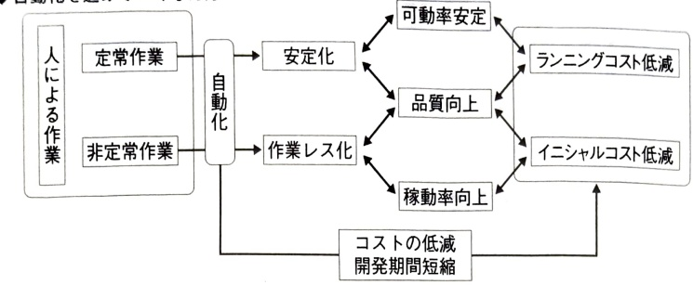
◆When automation is technically and economically difficult
Figure 4.3.4 How to proceed with automation in consideration of quality and cost in production
・Return the sent jig (unit) to its original position
・Remove the processed workpiece from the jig (unloading)
・Attach the workpiece to the jig (loading)
・Send to next process
Figure 4.3.4 illustrates the basic concept of automated line construction. Work by humans.
· Regular work
·Irregular work
There are two types: standardization and automation of non-routine work is delayed and human error tends to occur. Maintenance of equipment and handling short-term outages are non-routine tasks, so we will standardize the areas that can be standardized to improve the reliability of work and improve quality. When automation is technically and economically difficult, KM management is effective for improving the reliability of human work.

7) Planned and organizational use of process FMEA
The process control plan specifies the quality characteristics and limits that should be guaranteed in each process in the mass production stage.
reveal. Additionally, confirm that non-conforming products are not received, produced, or distributed. Utilization of process FMEA is essential to uncover potential nonconformity (failure) modes in process design, implement fundamental countermeasures, and realize vertical startup.

8) Initial management system for equipment formation
Management of equipment formation is important not only from the perspective of building quality in the process, but also from the perspective of investing management resources.
Since the initial equipment management system is developed mainly through product development, regulations regarding the necessary documents are often unclear during the process from equipment planning, basics, and design to initial flow management. In addition, in the evaluation of production prototypes, emphasis has been placed on evaluation of prototypes made using the same equipment and jigs as those used in the mass production stage (so-called all-tooling), and appropriate operation of the initial management system is becoming increasingly important.
For this reason, it is important to develop an equipment management system when making decisions about equipment configuration. As the schedule until the start of mass production has become shorter as a result, unreasonable compression of the equipment production period may lead to deficiencies in the items to be checked, which may result in additional or modified work being required, which may cause the transition to actual operation to be significantly delayed compared to the plan.The quality and cost of equipment can also be greatly affected by the quality of the equipment's initial management.
Table 4.3.5 shows an example of the maintenance status of the equipment initial management system.

9) Planning and implementation of equipment inspections and inspections
We will rationally determine inspection points, inspection items, inspection methods, and inspection intervals, and promote rational equipment management that has a large impact on quality and productivity. Overall equipment efficiency as an evaluation index takes both quality and productivity into account, and is benchmarked at over 85%.
Table 4.3.5 Example of maintenance status of initial equipment management system
step | Rules governing the initial management flow | forms
Products and regulations | Products and regulations | equipment
Planning concept design detailed design | Process change management regulations Technology development management regulations Quality equipment management regulations | List of research and technology development themes Technology development theme list Technology development plan (including contractors) Technology development checklist Research contractor certification record Equipment development plan | (Conceptual design) 1. Conceptual design specifications 2. Equipment budget 3. Estimate specifications 4. Estimate (detailed design) 5. Execution budget 6. Design specifications 7. Design drawings 8. Work execution guidelines
Order manufacturing installation trial run | Technology development management rules | Monthly reports and reports Consignee progress report meeting Materials consignment Monthly report Development management meeting minutes Technology development review list Development verification report Equipment progress report Equipment development review list Equipment completion report | (Order/Production) 9. Order specifications 10. Production specifications 11. Detailed design drawings 12. Production drawings 13. Production schedule (installation/trial run) 14. Installation work instructions 15. Completion documents 16. Trial run plan 17. Work standards 18. Acceptance inspection report 19. Safety inspection checklist
initial flow | Initial flow management rules | Monthly reports, preliminary reports, reports, development management meeting minutes, development verification documents, work standards, technical standards, initial flow management implementation table | 20. Construction report 21. Prototype report
MP information |  | Sales information, process change request form, customer complaint information, operational information, nonconformity management table, patent information, evaluation report of other companies' products, literature information, breaking news, report documents | 22. Abnormal failure information notification form

① Daily news
Since this is carried out while the equipment is in operation, it is possible to detect rapid deterioration mainly in a relatively short period of time by checking the appearance.

② Periodic point
This is carried out on factory repair days or during equipment inspections, and mainly involves checking the appearance of equipment for abnormal deterioration, and measuring using simple measuring instruments (various gaps, liner wear, loosening of fasteners, etc.).

③ Periodic inspection (inspection usually includes inspection)
On factory repair days, equipment is disassembled and opened, and various measurement and inspection instruments are used to quantitatively assess the equipment condition (shapes and dimensions of shafts, gears, impellers, etc., tank thickness, non-destructive inspection for cracks, etc.).

④ Inspection of dependence
The operation department primarily requests the maintenance department to inspect abnormal phenomena such as unusual noises, heat generation, and vibrations during equipment inspections, and takes measures to deal with abnormal deterioration that cannot be supported through daily inspections.

4.4 Main challenges and responses in the new product development process
The quality of products and services, as shown in the design process example in Figure 4.4.1, is the result of the output of business processes such as new product development and production, and is closely related to the quality of business processes. By analyzing quality problems occurring in the market, etc., and providing feedback to improve the work that has been overlooked, the aim is to improve design and manufacturing quality, and improve product quality. In other words, if you work in a team that is open to the external environment and emphasizes good communication and discussion so that the potentials of individuals and groups complement each other, you can expect good output.

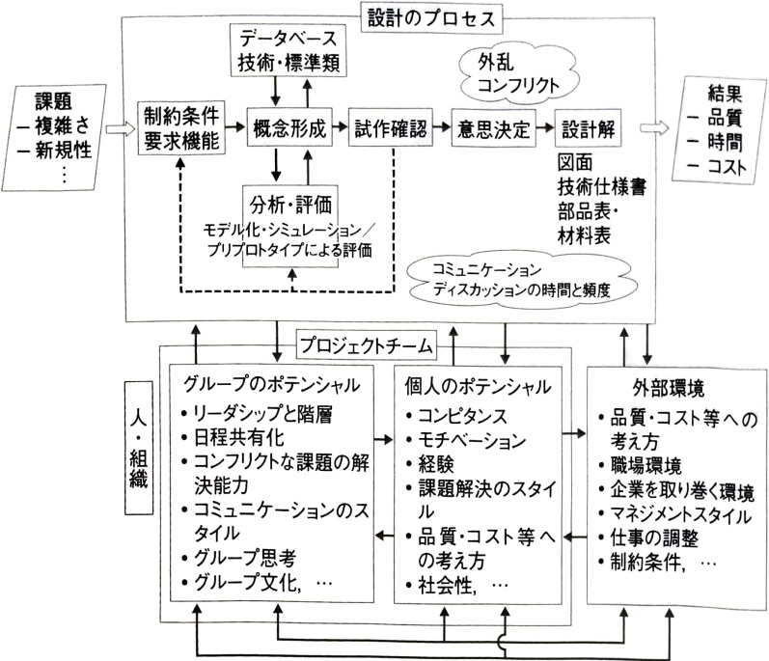
Figure 4.4.1 Interaction between people and organizations in business processes
Regarding complementarity between people and groups, as shown in Figure 4.4.1, the potential of groups is
・Leadership and management
·coordination
・Work design and schedule sharing
・Ability to resolve conflicting issues
・Communication style
・Group thinking
・Group culture
is important. Also, in terms of individual potential.
・Competence (technical, human, conceptual skills)
·motivation
・Experience (general work, etc.)
・Problem solving style (preliminary verification, modeling/simulation)
・Thoughts on quality, cost, etc.
・Social skills (listening skills, etc.)
becomes important.
70 to 80% of market quality problems are created at the design stage, but problems caused by design work often remain latent. Problems such as aging do not occur in the concept or drawing itself. However, if we evaluate things in terms of objects, what was latent in the drawings may become apparent. Even if it does not become apparent during prototype evaluation, it may become apparent after it is distributed in the market.
Here, we will discuss quality issues at the design stage.
· Drawing completion level
· Prototype evaluation
・Quality confirmation during mass production transfer
From these perspectives, we will clarify guidelines for reviewing the new product development process and link it to process improvements.

(1) Why is the degree of completion of the drawings low?
One of the important outputs of design is drawings. When problems with drawings become apparent in the later stages of development, the scope of influence, including process design, expands. If fundamental measures are difficult to take, it will also affect production and quality in the market.
Problems with many design changes and low completion of drawings include:
・Lack of broad and deep consideration of concept drawings and planning drawings at the early stage of development
・Problems with work design that involves participation in post-processes such as production from the stage where there are no drawings

Table 4.4.1 Why is the level of completion of drawings low?
Problem | cause | Guidelines for countermeasures
1. Frequent re-design | -There is no broad and deep consideration at the conceptual drawing/planning stage, and development is tied to the prototype production schedule. -Insufficient support from the parent organization, and the potential of each individual directly determines the quality of the product.Problems are overlooked during DR, and not all are extracted. -During DR/prototyping All identified problems have not been cleared by the drawing stage. Product functionality and productivity requirements are different. Regarding productivity, new requirements such as adding ribs to improve melt flow often occur in the late stages of development. Information necessary for design is not accumulated and inherited. | · Create a development process that allows downstream processes to participate at the same time → Concurrent engineering is also necessary from the perspective of building quality · Inject management resources from an early stage of development · Create a system that allows downstream processes to share the same problems from an early stage → Rich communication that utilizes colocation and the five senses · Development based on new ideas to resolve conflicting problems → Is it from a product life cycle perspective? How to proceed with development management that incorporates the concept of risk from securing schedules - Enhancement of information and evaluation techniques and tools at the conceptual stage → Clarification of expressions and key points by parameterizing functions - Establishment of values and mechanisms for how to complement the organization, such as DR - Regarding DR, think about how to utilize it in each department rather than pointing it out - Extract expert opinions - Mechanism and revitalization of new elements and change management
2. Requires more design man-hours than planned, causing schedule delays. | ·Inefficient design work due to insufficient use of information technology and design rework ·Inappropriate development plan due to insufficient understanding of the concept of backward scheduling ·Lack of leadership from managers, including clarification of conflicting issues and resolution policies, resulting in loose schedule management
3. Defects that cannot be confirmed during design occur. | ·Design and evaluation ·Insufficient sharing of information with production departments, etc. ·Interface-related defects such as current wrap-around, small gaps, and interference become apparent during evaluation of actual equipment in the late stages of development ·Lack of standardization efforts and recognition of their importance
4. Troubleshooting tends to be an ad hoc response by the person in charge. | · Lack of information sharing and collaboration with technology, production engineering, production departments, etc. · Especially when dealing with problems that occur in the later stages of development, there is a strong tendency to rely on trial and error methods because they want to resolve them in a short time.
5. Development is not done in a timely manner because process design and consideration of outsourcing manufacturers begins after drawings are issued. | ·Due to the serial development system, it is difficult to develop by sharing and sharing information across departments ·There is no ingenuity in participating in post-processes including manufacturing in the early stages of development when there are no drawings
Details of these problems and countermeasures are shown in Table 4.4.1.

(2) Problems in development prototypes and countermeasures
Development prototypes are used to evaluate the design of products to identify the presence or absence of problems, and if problems are found, they are fed back to the design for improvement. They are also an important source of information when making step-up decisions, and play an important role in preventing quality problems from leaking into subsequent processes.
Problems in developing prototypes include:
- Coordination with prototype flow is often an issue. In addition to utilizing external manufacturers specializing in prototype production, it is necessary to shorten the lead time for prototype confirmation by providing education and training, such as in-house training of skilled workers.
・Improve the evaluation system for non-conforming product analysis after prototype evaluation
etc. Details of the problem and countermeasures are shown in Table 4.4.2.

(3) Procedures for confirming the quality of designed products during mass production transfer
Once design, prototyping, and evaluation are complete, mass production will begin. If information sharing is ensured between the design and production departments from the early stages of development, there will be fewer problems when mass production is transferred.
Information sharing within the design and production departments is more advanced than between departments. Efforts are being made to standardize information sharing between departments and improve databases, but information is often transferred through people. for example,
- Improving the accuracy of man-hour input, such as resource input from the early stages of development, is often an issue. It is necessary to clarify the development process, necessary activities, and the relationship between these and management resources. The manufacturing process is visualized using this idea.
・When working in a cross-sectional team or conducting a design review, it is important to set up and operate a place where information can be shared and skills can be drawn from each expert.

Table 4.4.2 Problems in development prototypes and their countermeasures
item | Problem/Cause | Measures details
① Development experiment prototype schedule is delayed | ・Schedule setting is unreasonable ・Prototype schedule fluctuates frequently (external factors: equipment failure, engineer absent due to emergency requirements) | ・Every month, notify the production control department in writing of the next month's trial production schedule, adjust the mass production flow schedule, and establish rules to clarify the trial production end date.
・Since many processes depend on engineers, 24-hour flow is not possible. | ・Create operational strategies to clarify the information required by line operators and ensure accurate communication of information without any delays so that prototype production can be carried out 24 hours a day.
②Many prototypes | ・Changes in customer requirements (specifications) occur due to market demands, such as individual process/device specifications required from a product specification where development target specifications often change.Many items cannot be set initially. | ・Reliably finalize specifications and conduct DR at the product consideration stage ・Due to the nature of new product/new process development, changes in specifications are unavoidable, so make sure to review the development plan when changes occur.
・Experimental prototype production Low compliance rate with target values ​​・Additional experimental prototype production is required due to the occurrence of defects due to omission of evaluation items.While automation of measurement is progressing, the attention of development staff to detailed characteristics is decreasing. | ・A cross-departmental multi-functional team will be formed according to the process development flow, and thorough preliminary examinations will be carried out, including DFMEA, critical modeling and simulation. ・Individual development items will be worked on by each specialized department through multi-functional teams to improve the accuracy of achievement.
③ Long time required for evaluation (measurement) | ・Evaluation tools are not sufficiently developed | ・Create a device schedule to eliminate measurement/evaluation time due to batching of usage time
・In the case of new elements and non-conforming product analysis, it is difficult to estimate the time, including the evaluation method. | ・Create a roadmap for the development of measurement/evaluation tools that is linked to the process development roadmap, and systematically develop an organizational infrastructure that can efficiently carry out concurrent development.
④ Lack of engineer resources | ・Development item priorities have not been set and engineer power has not been allocated effectively. | - Integration of technology and new product development through horizontal deployment of development technology - Clarify the image of human resources by clarifying the skills needed in the future, promote human resource development in a strategic and planned manner, and create an environment where people can grow through a participatory organization (activation of OJT, improvement activities, etc.) (Educational Navigation System)
Table 4.4.3 Procedures for confirming the quality of designed products during mass production transfer
item | Problem/Cause | Measures details
development plan | ·It is impossible to proceed with the product development plan in line with the mass production schedule ·Many transfers are started before the delivery date is imminent. | - Agile response based on assumed scenarios using PDPC, etc. - Improved accuracy of resource input at the start of the theme - Reduction of lead time by resource input from the early stage of development and deep analysis
Initial flow management | - Prototype verification may not be carried out on a quasi-prototype line assuming mass production (mainly technical prototyping verification) - At the design prototyping stage, verification of process control ability is the main focus, and there may be no target yield, especially sensory test items (appearance, etc.) | · Add target yield to quality confirmation items at the design and prototyping stage · Clarify the purpose of design and prototyping (quality to be guaranteed, productivity, detection ability, etc.) and evaluate sequentially and systematically
Developing 4M conditions | [People/Knowledge] · Verification becomes biased during DR in a cross-functional team. Gap in product knowledge (especially FMEA) [Tools/Equipment] After the provisional line was launched, there was a delay in the design of mass production automated lines, etc., and the equipment was not designed to be foolproof, such as human error (FMEA was not implemented when mass production equipment design occurred) | · Improved skills as a cross-functional team (improved risk communication by strengthening FMEA in failure estimation, etc. for preventive and predictive measures) · Drafting and implementation of FMEA training plans for manufacturing managers and QA/production engineers/designers · Human errors when arranging new equipment, and procedures for implementing FMEA
Information sharing/sharing | [Information disclosure/explanation] The manufacturing department participates in DR, but the transfer plan is not clearly explained to the people in charge of promotion, especially those involved in the manufacturing department. | ·Create a production transfer application form and hold a briefing session ·Promote information sharing not only about design but also about new manufacturing points and changes related to production
etc. Details of the problem and countermeasures. It is shown in Table 4.4.3.

(4) Reducing design troubles through sharing and sharing information
A code that adds value to incoming information and transfers it to related people and organizations for sharing.
Communication is the basis for working efficiently. There are two aspects to information utilization. These are the so-called content (content of information) and where the necessary information is stored (related to search issues). Information and knowledge are not necessarily mature until they can be expressed and conveyed using the media of words and drawings. There is also fragmentary but important information that can only be conveyed in the form of ``this makes sense.'' In such cases, ``a place to convey or share information'' is also important, and the use of direct communication media can be very effective. In development, where you often encounter unknown things, it is important not only to have a place to communicate with reviewers that is set up and implemented in a planned manner, but also to create an environment for communication such as colocation as an organization so that it can be done immediately when needed.
Below, we will discuss possible examples of sharing and sharing information to reduce design problems.

1) Measures to reduce design troubles through information sharing and sharing
In design, quality problems may occur because information is not used accurately. Information has the characteristic of being able to be used multiple times, and utilizing accumulated information means that new management resources can be allocated to areas that need to be investigated from scratch. In an effort to reduce design problems through information sharing and sharing,
When changes from the past or innovation are involved, such as in development, it is desirable to effectively select and utilize a variety of information media, such as direct communication, depending on the type of information.
・If an environment is created in which the relationship between databases and business operations is clearly defined and provided from the second user's perspective, incentives for timely use and integration with other information will increase, leading to actions from sharing to accurate sharing.
Details of the initiatives are shown in Table 4.4.4.

2) Information sharing means and examples
Regarding information sharing as an organization, as shown in Table 4.4.5, forms and materials for input and output in the development process are often specified and standardized. Development work is multifaceted and involves many related organizations both inside and outside the country, making it difficult to automate the work and its reliability depends on people. We strive to achieve the goals of QCT by determining standards for activities and information flow, and by adhering to these standards, with the aim of sharing and sharing the organization's experience and accumulation and reducing dependence on people.
Regarding this kind of information sharing and sharing, we can observe a slightly different aspect of the actual situation. For example, as shown in Table 4.4.6,
・Information sharing methods may not be defined, but even if they are standardized, they are often not followed. Information about changes, etc. is only shared in the minutes, but feedback may not be provided to the drawings.
・One of the significances of standardizing the method for sharing information as an organization is that, as shown in Table 4.4.6, ``If business is carried out normally, business can proceed without using sharing methods,'' but ``depending on the manufacturer's ability, things may not always go smoothly, and when a problem occurs, there will be a delay in responding.''

etc.
The fact that changes may not be fed back and incorporated into the drawings suggests the importance of sticking to what has been decided. In addition to instructing and notifying changes, we also provide feedback and review information sharing methods such as drawings and technical specifications to clarify the current baseline. If information is shared in this way and the work flow and execution status are transparent, it will be discovered quickly if something goes wrong or a problem occurs. If you share the baseline and its background, you will be able to consider countermeasures from a bird's-eye view and take accurate and prompt responses.

Table 4.4.4 Measures to reduce design troubles through information sharing/sharing
No. | Activity item | Activity content | Information sharing/sharing management | Improving the organization and environment through meeting bodies, etc.
1 | Basic policy for project management | ① Share vectors among development members by clarifying strategies and goals | 1. Centralization and sharing of information ① Centralization of information to project D/B and multi-layered learning ② Sharing and coordination of values through a once-a-week review meeting of related departments ③ Management of new elements and changes through comprehensiveness and visualization 2. Sharing schedules ① Overlapping development phases and self-organizing project teams ② Unifying the schedule from design consideration to production equipment ③ Improving the accuracy of estimating man-hours and loads ④ Wall charts and process charts 3. Early clarification of issues and efforts ① High goal setting and great freedom/diversity of rhythm ② Identification of issues in design and equipment ③ Identification of problems and problem solving by teams and organizational transfer of learning (successes and failures) 4. Sharing analysis data ① Utilizing DfX from a product life cycle perspective ② Utilizing 3D-CAD/CAE analysis and data between departments as data for DR, cost review meetings, mold production, etc. 5. Utilizing mini DR ① Innovating two-way communication between designers and reviewers ② Emphasizing the design concept (DesignView) | (1) Open workplace management through general meetings (all departments), etc. (2) Building an environment that prevents easy efforts by focusing on the field (3) Utilizing direct communication through mini DR/colocation/collaboration (4) Knowledge adapted to the situation within the organization Installing transformers in each department to convert external information into cognitive forms to promote information sharing and support team activities. (5) Data for each department is extracted from each department and discussed interactively. (6) Establishment of an evaluation system for group performance. (7) Self-organization and active support of partner companies.
2 | Demonstrate leadership | ①Network construction
3 | Building a support system through interdepartmental cooperation and cooperation | ① Quality of information and communication/effective use of information media
② Parallel consideration and early identification of issues
③ Flexibly coordinate with related departments depending on the situation
④ Elimination of waste and extra time
4 | Improving the completeness of drawings and streamlining design work | ① Accumulation and utilization of know-how in related departments
② Utilization of standards and standards
③ Extraction of past success/failure experiences
④ Utilization of IT such as 3D CAD, CAE, etc.
⑤Shorten prototyping cycle
⑥ Planned education and training
5 | Sharing of database between departments | ① Market quality information such as complaints, CS, etc.
②Technical information, design trouble case studies
③Productivity information such as process defects, setup/adjustment, cycle time, etc.
④Materials/parts/outsourcing processing costs
⑤Logistics costs
Table 4.4.5 Examples of information sharing methods
development phase | mission | Necessary information | Means of information sharing | Department in charge
When selecting a manufacturer | Presenting development conditions to manufacturers | Supplier information (new technology, etc.) | Briefing session, manufacturer materials | design
Manufacturer selection conditions (number of units, cost, etc.) | Manufacturer selection request form, cost survey request | design
Parts specifications (concept, shape, type, etc.) | requirements specification | design
Required performance and quality of parts | requirements specification | design
Manufacturer capabilities (production equipment, evaluation equipment) | Manufacturer evaluation report | Design/purchasing
Is a guest engineer necessary? | Manufacturer selection request form | design
Understand the development schedule | Manufacturer selection request form | design
When deciding on the manufacturer | Check the manufacturer's order conditions | Contents of decision specifications (including cost and investment) | Reply to manufacturer selection request form | purchase
Contents of decision specifications (including details of content and target quality) | Manufacturer quotation specifications | Purchasing/Manufacturer
Contents of the contract | requirements specification | Purchasing/Manufacturer
When determining specifications | Mutual confirmation of detailed design conditions and study results | Product side constraints (layout, performance) | Planning data, requirements specifications | design
Product side constraints (quality) | Planning data, requirements specifications | design
Constraints on the production side (methods, processes,…) | Technical specifications | Manufacturer/Design
Supplier considerations at the technical review meeting | Technical specifications | Manufacturer/Design
Contents of specifications according to technical specifications | Technical specifications | Manufacturer/Design
Design information requirements | drawing, intersection | Manufacturer/Design
Supplier technology plan | plan | Manufacturer/Design
Material specifications | Technical specifications | Manufacturer/Design
Cost and investment information at intermediate stages | Intermediate stage estimate presentation materials | Manufacturer/Design
Quality build-up status at mid-stage | Technical specifications | Manufacturer/Design
Table 4.4.5 Examples of information sharing methods (continued)
development phase | mission | Necessary information | Means of information sharing | Department in charge
When issuing new drawings | Drawing approval | Surrounding information that led to the shape decision | Technical specifications | Manufacturer/design
Certification of quality assurance (results of design verification) | Plan drawings, technical specifications | Manufacturer/design
At the time of mold creation (during development) | Raising nonconforming items | Development drawing status | Quality problem management table | Manufacturer
When building quality (during development) | Claiming an item | Quality nonconformity items and their countermeasures/schedule/person in charge | Defect management table | Quality/Experiment/Manufacturer
At the time of mold making (at the time of mass production) | Confirmation of ball formation level | Production status of mass production drawings | Technical specifications | Manufacturer/design
Are the molding conditions clear? | Target quality control table | design
When building quality (during mass production) | confirmation | Quality nonconformity items and their countermeasures/schedule/person in charge | Defect management table | Quality/Experiment/Manufacturer
Evaluation results for target quality | Target quality control table | design
At the start of mass production | Prevention of leakage of non-conforming products | Mass production quality confirmation | Mass production quality evaluation report | quality
If you consider and implement countermeasures based on local information, new problems will arise one after another, and you will likely fall behind and fall into a negative cycle. Standardizing and adhering to this will encourage the sharing of information, including context, and reduce the risk of things going wrong.
Although it is important to prevent problems from occurring, this alone may be a narrow response within the scope of what the parties can do. It is essential to consider the impact if it occurs. When envisioning a problem, it is important to maintain a delicate balance between logic based on the concept of risk, which considers the two-dimensional likelihood of occurrence and magnitude of damage, and logic that transcends this concept. This is management that incorporates two-pronged thinking, which not only prevents problems from occurring, but also mitigates the impact of their occurrence. To prevent catastrophic effects, it is necessary to think in advance of how to accurately prevent the chain from spreading, anticipating it to occur.
Table 4.4.6 On-site responses to information sharing measures and reasons why they were successful even without implementation
On-site responses and approaches to information sharing methods | current situation | Why it worked | Problem
Implemented by means other than specified | Meetings are held as necessary, and the minutes of the meetings are used instead. | Although it was thought to be tacit knowledge, it is being shared through other means. | Other measures have not been standardized, and there are variations in whether or not to implement them at the discretion of the person in charge.
Common sense in the 〇〇 industry in Japan | If the work is carried out normally, the work can be carried out without using sharing methods. | There were no problems because we had been working together for a long time and were on the same page (business customs). | Things don't always go well depending on the manufacturer's ability, and when a problem occurs, there may be a delay in responding.
Can recognize each other based on past performance | In the case of current manufacturers, their capabilities are well understood, and tacit sharing is possible. | There is implicit sharing with manufacturers with whom we have a relationship, and things often go well unless it is a new manufacturer. | Conventional tacit knowledge may not be viable due to differences in the level of the people in charge.
Implementation with delayed timing | Basic information is shared at this step of development and implemented in the next step. | This was carried out in the next step, resulting in more accurate sharing. | General information is shared by other means, and more accurate information can be shared in later steps.
In the development of new products, as shown in Figure 4.4.2, in addition to creating a database, we will promote the sharing of information using multifaceted media such as collaborative FMEA as a team, and standardize and improve business processes related to preliminary verification, such as preliminary verification in case something goes wrong, and work design that incorporates the perspectives and knowledge of others through the use of design reviews. Furthermore, we will ensure that standards are followed through education, training, on-the-job training, etc., and if any problems are found, we will make improvements and reforms.
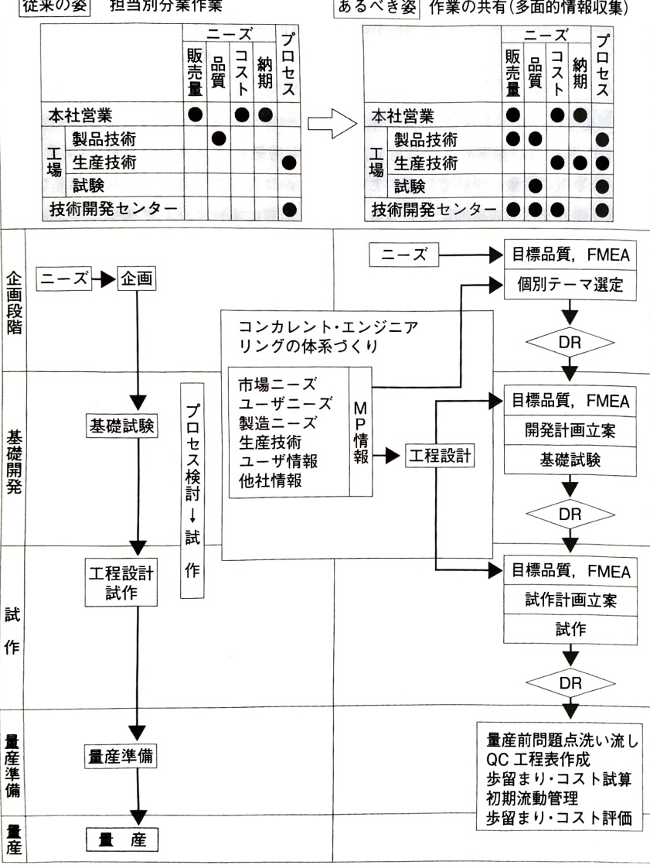
Figure 4.4.2 From sharing information to sharing work in new product development (management of preliminary verification using FMEA)

Part I Exercises
Problem 1 On January 28, 1986, the US Space Shuttle Challenger exploded 72 seconds after liftoff, killing all seven astronauts. The following has been clarified regarding the facts and background of the accident. Based on these facts and background, consider what is necessary to ensure that what is technically envisioned is put into practice and linked to prevention.
[Facts] A cold wave hit Florida several days before the launch, and the temperature near the surface of the right solid-fuel rocket, which was exposed to the wind on the launch pad, at one point dropped to -22 degrees Celsius.
The outer wall of a solid-fuel rocket has a structure that connects four cylinders, and the joints are sealed with synthetic rubber O-rings and putty to prevent gas leaks.However, the synthetic rubber of the O-rings loses its elasticity at low temperatures, which reduces its sealing performance, and the safety of rockets at such low temperatures was not considered in the design standards.
The day before the launch, Alan MacDonald, the launch site manager at Cyacol, a manufacturer of solid-fuel rockets, was surprised to learn of the abnormally low temperature.He asked the engineering team at Cyacol's factory in Wasasachi, Utah, to investigate the situation, and also requested the National Aeronautics and Space Administration (NASA) manager to cancel the launch.
Almost all of Thiacol's technical staff were against it, but when NASA pressed for consent for the launch, Thiacol relented and its vice president signed the consent form.
[Background behind why NASA officials forced the launch]
① The Challenger launch had already been postponed twice due to a busy schedule of 15 launches per year and troubles.
② Children across the United States were looking forward to Mr. McAuliffe's lessons from space.
③ On the day of the launch, President Reagan was scheduled to speak about the achievements of the Space Shuttle program in his New Year's address.
Question 2 Referring to the following case law regarding product liability in the United States, consider reasonably foreseeable forms of use and explain your understanding.
(1) Explain the predictability of ``two people working together.''
(2) Explain the rationality of the foreseeability of ``two people working together.''
[Facts] One person was supplying material to a guillotine-type plastic cutting machine, and the other was operating the cutting blade. At this time, the timing of the two people went awry, and three of the supplier's fingers were lost. This machine was originally designed for one person and had a two-handed pushbutton type, but there was a risk that one button would be pressed and the other hand would be placed on the cutting part and the switch for the cutting blade would be operated with one hand, so the design was designed to prevent this by placing the switch on the side.
[Judgment] The court pointed out a design flaw, saying, ``Even though it was fully anticipated that two people would be working together, there was no safety device in place to prevent this.''
Question 3 List three ``coordination issues'' that are considered important as Japanese companies continue to globalize their business and aim for sustainable growth, and discuss solutions for each. In your essay, visualize the scheme of your consideration with illustrations, etc., and clearly state the logic so that the ``why'' is easy to understand.
Examples of design variables in coordination are:
· Business scale
・Specialization of equipment and personnel
・Location of business facilities
·Economies of scale
Estimated production scale of products using the same parts
Complementarity in terms of production
economics of a range
・Core competence
・Information transmission and decision making
centralized decision making
unilateral decision making
etc.
Question 4 Regarding the following ``Responses to new elements and changes,'' consider the key points that will lead to results by incorporating specific countermeasures into the new product development process.
(1) For new products and products with design changes, we thoroughly identify new elements and changes, accurately predict the possibility that they will lead to major product failures, and ensure design margins based on theoretical analysis, limit tests, etc. Additionally, we will implement FTA for important failure modes and ensure thorough management by reflecting control items in drawings, quality control point setting requests, and QC process charts.
(2) When launching a new product, advance product development ahead of schedule, sell as little as possible, and make changes after confirming market performance.
(3) When expanding product destinations, make sure to grasp changes in the usage environment and thoroughly confirm that the initial design margin is maintained.
(4) For design changes made by VA/VE, thoroughly evaluate the disadvantages and ensure reliability.
(5) We will enhance design review mechanisms and tools to thoroughly analyze the effects of new elements and changes, and systematize past know-how for each product and thoroughly educate young engineers.

Part I References
[1] Kazuhiro Ota (2000): “Management Renaissance through TQM”, “Quality Control”, Vol. 51, No. 7, pp. 21-30, Japan Federation of Science and Technology.
[2] Ken Kusunoki (1996): “Organizational capabilities and product development performance of Japanese companies—A comparative analysis by industry type,” Business Review, Vol. 43, No. 4, pp. 23-46, Chikura Shobo.
[3] Clark, K. B. & S. C, Wheelwright(1993) : Managing New Product and Process Development, Tavistock.
[4] Christensen, Anthony, Ross (2005): “Who Will Tomorrow Belong to? The Final Solution to Innovation” (translated by Kiichi Miyamoto), Random House Kodansha.
[5] Collins, Porras (1995): Visionary Company (translated by Yoichi Yamaoka), Nikkei BP.
[6] Collins (2001): “Visionary Company (2) Laws of Leap” (translated by Yoichi Yamaoka), Nikkei BP.
[7] Simon (2009): New Edition of Management Behavior: A Study of Decision-Making Processes in Management Organizations (Kotaro Kuwata, Nobuko Nishiwaki, Mika Takayanagi, Yoshiaki Takao, Toshiko Nimura), Diamond Publishing.
[8] Mitsuteru Shimaguchi, Hirotaka Takeuchi, Hidetaka Katahira, Junzo Ishii (1999): Product Development Innovation, Yuhikaku.
[9] Yasuhiko Seki (1996): “Improving the level of quality assurance through the use of the “guarantee network,”” 30th Q-S National Conference Reports, pp. 95-102, Japanese Standards Association.
[10] Hiroshi Takamatsu, Tadayoshi Ooka (1986): “Using QC process charts: Quality development at the production preparation stage (from QA charts to QA process charts)”, Standardization and Quality Control, Vol. 39, No. 8, pp. 77-88, Japanese Standards Association.
[11] Tidd, Pavitt, Bessant (2004): Management of Innovation—Integrated Management of Technology, Markets, and Organizations (translated by Akira Goto and Jun Suzuki), NTT Publishing.
[12] Tedrow (2011): “Why leaders cannot admit failure” (translated by Nami Hijikata), Nihon Keizai Shimbun.
[13] Paashuis, V(1998): The Organisation of Integrated Product Development. Springer.
[14] Heisenberg (1974): Part and Whole (translated by Kazuo Yamazaki), Misuzu Shobo.
[15] Tsutomu Harada (1999): “Management Studies of Knowledge Conversion—Structure of Knowledge Interaction”, Toyo Keizai Inc.
[16] Finkelstein (2004): “Why do great managers fail?” (Taisuke Sakai (translator), Hiroshi Hashiguchi (supervisor), Nikkei BP.
[17] Masahiko Miyagi (2010): “Improving the reliability of automotive parts and training engineers at DENSO,” “40th Reliability and Maintainability Symposium Collection of Presentations,” p. 67, Japan Federation of Science and Technology.
[18] Tetsuo Miyamura, Hajime Makabe (1994): “Research on quality assurance issues for preventing product liability based on case analysis of product liability,” Quality, Vol. 24, No. 3, pp. 91-103, Japan Society for Quality Control.
[19] Tetsuo Miyamura, Hajime Makabe (1994): “Research on the prevention of product defects in terms of product liability,” Quality, Vol. 24, No. 4, pp. 59-72, Japan Society for Quality Control.
[20] Tetsuo Miyamura (1999): “Generation of knowledge dynamics through DR—a consideration from a metacognitive perspective in organizations”, “Quality”, Vol. 29, No. 2, pp. 68-78, Japan Society for Quality Management.
[21] Tetsuo Miyamura (1999): "Information/Communication and Organization in Concurrent Engineering - Improving Drawing Quality at the Conceptual Stage", "29th Annual Conference Research Presentation Abstracts", pp. 37-40, Japan Society for Quality Control.
[22] Milgrom, Roberts (1997): Economics of Organizations (translated by Masahiro Okuno, Hidefumi Ito, Haruo Imai, Osamu Nishimura, and Ho Yagi), NTT Publishing.
[23] Young (2005): “CSR Management – ​​Moral Capitalism” (Fujiko Hara, Keizaijin Co.
Translated by Round Table Japan Committee), Productivity Publishing.
[24] Akira Yoshimura (1982): “Type 0 Fighter”, Shincho Bunko.
[25] Tatsuhiko Yoshimura (1999): “Thoughts on Good Design etc. in Toyota Motor Vehicle Prevention”, “29th Reliability and Maintainability Symposium”, Japan Reliability Society.

Part II

Management that incorporates the concept of reliability
Incorporating reliability considerations, such as changes over time, into the evaluation and design of new product development processes changes the way work is done, and affects the way we focus on markets and customers, and the scope of consideration.
In terms of aging, information on failure patterns, or the concept of failure rate, is important as well as reliability. Inspection and testing are effective for wear-out failure types, where the failure rate increases with age, and screening is the deciding factor for early failure types, where the failure rate decreases.
A systematic approach is effective in anticipating failure modes and keeping risks below acceptable levels. When designing a system, reliability allocation and prediction are carried out by taking into account the relationship between reliability of elements and the system. Additionally, in order to consider the relationship between elements and the impact on users, it is necessary to look at the configuration.
Furthermore, quality risks are identified and managed from business processes. It is important to promote organizational learning by horizontally deploying the development experience of individual products and services, and to incorporate learning rejection even if it is inconvenient information, and utilize it for prevention.

Chapter 5 Elements of Reliability
Reliability is a quality that takes into account the parameter of time.
The quality of usefulness changes over time. Change can be considered in terms of products and systems, the people who use them to obtain benefits, and the external environment.
Durability, ``resistance to breakage,'' is important when it comes to changes over time at the product or system level. As the saying goes, ``If the place changes, the product changes,'' and it can also occur in combination with stress from the external environment. When using a product for a long period of time, maintainability is important in terms of ease of repair, including inspection and inspection for changes, as well as restoration.
When the phase shifts from development to use, the subject changes from those who create products and systems to those who use them. Thinking and knowledge change depending on the person, and there are large changes between the creator and the user. This is one of the causes of misuse and human error. At the design stage of products and systems, manufacturers must give due consideration to human reliability, which is related to ease of use, to prevent human errors from occurring.

5.1 Durability
Durability is one of the reliability factors, such as ``long time to failure'' or ``few failures.'' We will define the meaning of failure, and then consider a scale for quantitatively evaluating durability.

(1) Concept of failure based on function

1) Focus on function
If a machine that was previously in motion stops and does not move, or if the cover or housing is damaged, it is said to be malfunctioning. If we use the word ``function,'' which means ``work,'' it means that something is in a state where it cannot perform its functions. Since covers and housings are stationary, their functions are difficult to see, but they perform functions such as ``protecting equipment'' or ``installing equipment.''
From this perspective, the function of a system composed of multiple elements is
・Essential function: A function required to fulfill the intended purpose of a product, device, or part (e.g., the function of a hydraulic pump to increase the pressure of oil)
• Auxiliary function: Function necessary to support the basic function (e.g., liquid retention function of a hydraulic pump)

It can be divided into two.
Basic functions are also called required functions because if they are lost, the value itself is lost. The specific contents of the auxiliary functions vary depending on the method used to realize the basic functions. In the case of hydraulic pumps, in order to increase the oil pressure, a function to confine the oil is required, so the pump has a structure with a casing or cover. The content of auxiliary functions becomes clear as the design progresses from function to mechanism to structure. Even the loss of an auxiliary function has a chain reaction that ultimately leads to the loss of the basic function.
More functions,
• Protective function: Function that protects people or equipment (e.g. pressure safety
(masu)
・Information function: Functions such as monitoring and alarms
・Interface function: A function that serves as an interface between devices and parts.

It may be classified as
Protection functions and information functions are functions that are required when a failure occurs in a system or device.保護機能は故障等の影響が連鎖的に拡大することを防止する機能で，故障の影響を緩和するために必要とされる機能である． Buildings designed to alleviate the effects of stress from the outside world are also an example of protective functions.
The information function monitors and communicates the status of equipment to control equipment and people, and controls separation from the system and transition to an appropriate state. Although these functions are not basic functions at the system level, they become basic functions when considering the functions of the parts themselves such as safety valves and sensors.
Interface functions can be considered to be included in auxiliary functions, but they are necessary for connecting with other equipment and parts through piping and cables. The sliding surface and the seat surface when fastening also have an interface function. Interface functions are important in systems consisting of multiple elements. Physical interfaces are easy to understand, but information functions cannot be communicated unless higher-level interfaces such as protocols match. Being aware of interface functions may not be noticeable from a reliability design perspective, but it is an important matter. For example, since test conditions change depending on the installed state, interface information is essential to improve consistency between market and bench test results.

2) Aging and failure of functions
When evaluating or expressing a function quantitatively, a functional principle diagram is used. In the case of a hydraulic pump, the Q-P characteristic, which shows the relationship between the shaft input and rotation speed, the amount of oil that can be discharged Q (l/min), and the discharge pressure P (MPa), is the operating function principle diagram, as shown in Figure 5.1.1. Specifically, input energy L₁ (kw) of rotation speed N₁ (rpm) is converted.
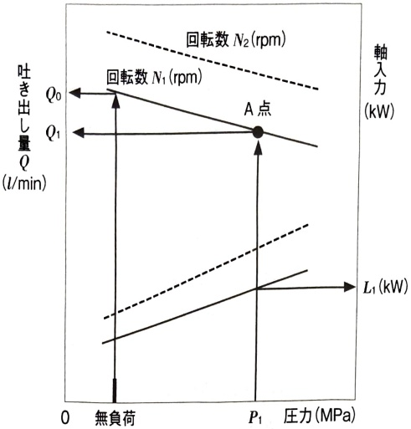
Figure 5.1.1 Q-P characteristics of hydraulic pump
Then, $ Q_{1}(l/\mathrm{min}) $ of oil with pressure $ P_{1}(\mathrm{MPa}) $ is discharged.
The definition of a failure is that if the discharge rate Q (l/min) of the pump's Q-P characteristic is required to be at least Q₁' (l/min), if the discharge rate decreases to below Q₁' (l/min), it will be below the functional limit and will be considered a failure. If the function deteriorates as shown in Figure 5.1.2, the time until failure occurs will be t.
Performance, which is the level of functionality, changes in the direction of deterioration over time, and a state in which the functional limit is exceeded is a failure. Judgment of failure changes depending on the definition of functional limits. Since products and systems have multiple functions, it is necessary to clarify which function has reached its functional limit, and this is called a functional failure mode. Functional failure modes can also be understood as changes at the physical level such as wear and cracks, and these are called failure modes. In order to rationally proceed with evaluation and design with reliability in mind, as well as consideration of maintainability during use, we will clarify the functional limits and examine the relationship between these and failure modes. The details of the concepts and assumptions regarding functional failure modes and failure modes are systematically described in the FMEA section of Chapter 11.
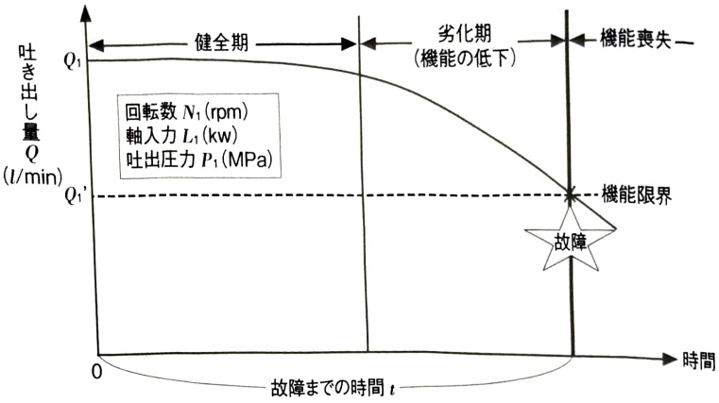
Figure 5.1.2 Hydraulic pump discharge pressure deterioration pattern and failure

(2) Durability evaluation scale
Although it is not possible to predict in advance the time until failure, it is possible to predict probabilistically whether or not a failure will occur by time t. It is also possible to predict probabilistically how many times a failure will occur in a given period of time. Therefore, it is possible to consider a durability evaluation scale by focusing on the time until failure occurs and the number of failures within a certain period of time.

1) Evaluation scale focusing on time until failure occurs

① Reliability
Reliability is the probability that a device will function without failure until time $t$ after it is first used, and this is expressed as $R(t)$. Since the probability of no failure does not increase over time, $R(t)$ is a non-increasing function of $t$. When we clarify that $R(t)$ is a function of time, it is called a reliability function.
The meaning of reliability and how to obtain it are explained in detail in Example 5.1.1.
[How to find reliability from histogram]
From the histogram, the reliability can be calculated as follows according to the definition. In the histogram in Figure 5.1.2, the reliability at 6,085 hours, which is the lower boundary value of class number 2, is 66/70 = 0.953 = 95.3% because the initial total number of samples n is 70 and the remaining number at 6,085 hours is 66. The reliability $R_{i-1}$ at the lower boundary value $T_{i-1}$ of class i can be generalized and expressed as
$$ R_{i-1}=\frac{\sum_{j=i}^{k}f_{j}}{n}=\frac{n_{i}}{n},\left(n_{i}=\sum_{j=i}^{k}f_{j}\right) $$
becomes. Here, $ n_{i} $ is the number of non-faulty samples in $ T_{i-1} $, and is also called the remaining number.
When calculating the reliability for the lower boundary values ​​of other classes, the results are shown in Table 5.1.3.
The reliability obtained in Table 5.1.3 is illustrated in Figure 5.1.4. In this figure, the reliability between class boundary values ​​is determined by linear interpolation.
Table 5.1.3 Reliability determined from histogram
number number | Class boundary value $ T_{i-1} \sim T_{i-1} $ | Frequency $ f_{i} $ | Remaining number $ n_{i} $ | Reliability $ n_{i}/n $
1 | 30.85 ~ 60.85 | 4 | 70 | 1.000
2 | 60.85 ~ 90.85 | 9 | 66 | 0.942
3 | 90.85 ~ 120.85 | 10 | 57 | 0.814
4 | 120.85 ~ 150.85 | 18 | 47 | 0.671
5 | 150.85 ~ 180.85 | 13 | 29 | 0.414
6 | 180.85 ~ 210.85 | 7 | 16 | 0.228
7 | 210.85 ~ 240.85 | 5 | 9 | 0.129
8 | 240.85 ~ 270.85 | 3 | 4 | 0.057
9 | 270.85 ~ 300.85 | 1 | 1 | 0.014
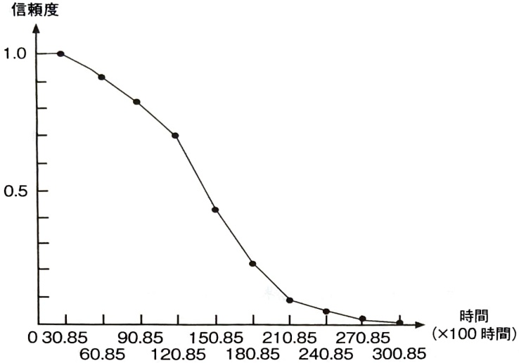
Figure 5.1.4 Reliability graph
[Theoretical explanation and definition of reliability]
In probability theory, variables whose values ​​cannot be determined in advance, such as the time until failure, but whose probabilities of possible values ​​are determined are called random variables. When the time until failure is denoted by T, the reliability R(t) at time t is expressed as the probability that T takes a value larger than t.
$$ R(t)=P(t<T) $$
It can be defined as T is a random variable.
The flow of calculating reliability from a histogram can be explained as follows. In [Example 5.1.1], the individual electronic components whose lifespan data are observed are called samples in statistics, and the source from which the samples are extracted (corresponding to drawings, processing steps, etc. of the electronic components) is called the population. Let's apply the idea of ​​observing the lifespan data of electronic components, dividing it into classes, and illustrating it as a histogram to a population.
Since the shape of the histogram changes depending on the number of samples $n$, it may be more convenient to express it in a way that does not depend on $n$. If the width of the class is $h$, the area of ​​the entire column is
nh, so to make the area of ​​the entire column 1 regardless of n, change the value of the vertical axis from the frequency f,
$$ \frac{f_{i}}{nh}=\frac{f(T_{i}=t,T_{i+1}=t+h)}{nh} $$
Here, to specify that the frequency of the class greater than $t$ and less than or equal to $t+h$ is $f_{i}$, it is expressed as $f(T_{i}=t, T_{i+1}=t+h)$. If $n$ is increased, the class width $h$ becomes $h\rightarrow0$, and the above value is
$$ \lim_{n\to\infty}\frac{f_{i}}{nh}=f(t) $$
approaches. This limit value $f(t)$ is called the (probability) density function. The idea beyond deriving the concept of density function from a histogram can be illustrated as shown in Figure 5.1.5.
Using the density function $f(t)$, as shown in Figure 5.1.5(c), if $h$ is small, approximately
$$ P(x<T\leq x+h)\rightleftharpoons f(x)h $$
holds, and the reliability of time $ t $ is
$$ R\left(t\right)=P\left(t<T\right)=\int_{t}^{\infty}f(x)dx $$
becomes. Therefore, as shown in Figure 5.1.6, it decreases as time t passes.
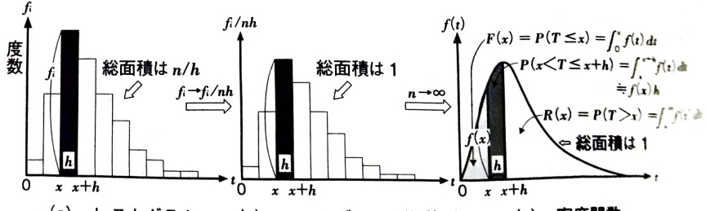
(a) Histogram
(b) Convert the scale of the vertical axis from fi to fi/nh so that the area of ​​the histogram is 1
(c) Density function
Figure 5.1.5 Flow of thought that leads to the concept of density function from histogram
Figure 5.1.6 Confidence and unreliability function graph
It becomes a function that does. Also, the probability of failure by time $t$ is called unreliability.
$$ F(t)=P(T\leq t)=\int_{0}^{t}f(x)dx $$
It can be expressed as a density function. In probability and statistics, this is called a distribution function.

② MTTF
$R(t)$ is a non-increasing function of time $t$ that changes with time. When comparing durability, it may be useful to have simpler characteristic values ​​that are not time-dependent. The concept of central value is often used for characteristic values ​​that represent a group, and one of them is the average. MTTF (Mean Time To Failure) is the average time to failure.
To find MTTF from data, use the arithmetic mean,
$$ \widehat{MTTF}=\frac{\sum_{i=1}^{k}f_{i}\overline{T_{i}}}{n}=\sum_{i=1}^{k}\overline{T_{i}}\left(f_{i}/n\right) $$
Here, $ \overline{T}_{i} $ is the center value of class i.

[How to find MTTF from histogram]
MTTF can be calculated from the classified life data as follows.
Table 5.1.4 Total sum of data obtained from frequency table (in units of 100 hours)
class number | Class boundary value $ T_{i-1}\sim T_{i-1} $ | Center value of class $ \overline{T}_{i} $ | Frequency $ f_{i} $ | sum of data of class $ f_{i}\overline{T}_{i} $
1 | 30.85～60.85 | 45.85 | 4 | 183.40
2 | 60.85～90.85 | 75.85 | 9 | 682.65
3 | 90.85～120.85 | 105.85 | 10 | 1058.50
4 | 120.85～150.85 | 135.85 | 18 | 2445.30
5 | 150.85～180.85 | 165.85 | 13 | 2156.05
6 | 180.85～210.85 | 195.85 | 7 | 1370.95
7 | 210.85～240.85 | 225.85 | 5 | 1129.25
8 | 240.85～270.85 | 255.85 | 3 | 767.55
9 | 270.85～300.85 | 285.85 | 1 | 285.55
 | sum of data | 10,079.20
Ru. If the data belonging to the class is represented by the center value of the class and the total sum is calculated from Table 5.1.4, it is 1,007,920 (hours), and dividing this by the number of samples $n=70$,
$$ \widehat{MTTF}=\frac{\sum_{i=1}^{k}f_{i}\overline{T}_{i}}{n}=\frac{1,007,920}{70}=14,399\quad(hours) $$
becomes.
[Theoretical explanation and definition of MTTF]
When $n\to\infty$, $\lim_{n\to\infty}\frac{f_i}{nh}=f(t)$, so if we express the MTTF of equation (5.1.1) using the density function $f(t)$, we get
$$ MTTF=E(T)=\int_{0}^{\infty}t f(t)dt=\mu $$
becomes. In other words. This is the expected value of the random variable T. this is. Using reliability.
$$ MTTF=E(T)=\int_{0}^{\infty}t f(t)dt=\int_{0}^{\infty}R(t)dt $$
It can also be expressed as
Note that (T-μ), which is the deviation from the mean μ, can be used as a measure to measure the dispersion of the distribution because the greater the dispersion of the distribution, the higher the probability that its absolute value will become larger. Actually, for ease of analysis, we take the square of the deviation and consider its expected value, the variance σ². this is,
$$ \sigma^{2}=\mathrm{V}(T)=\mathrm{E}(T-\mu)^{2}=\int_{0}^{\infty}(t-\mu)^{2}f(t)dt $$
It can be expressed as Variance is a characteristic value that measures the extent to which individual values ​​vary and are distributed from the mean, which is the center of the group. The square root of the variance is the standard deviation.

③ B_{10} Life
For each customer, the concept of the central value of the entire group is virtual. It is desirable to have characteristic values ​​that can guarantee that no failure will occur, or that the possibility of failure occurring is extremely small, at least up to this time. Reliability characteristic values ​​that are based on the concept of guarantee based on limit values, rather than average values, are required.
In addition to the central value, B₁₀life is a characteristic value that takes into account that the time to failure of individual samples fluctuates stochastically. This means the time when 10% of the time fails and the remaining 90% performs the required functions. If the target lifespan is taken as a limit value, it is possible to grasp the margin for the target by comparing it with the B₁₀life. If we replace 10% with α × 100%, we can define Bₐ × 100% life in the same way.

[How to find B_{10} life based on reliability]
From the reliability obtained in Figure 5.1.5, $ B_{10} $ life can be calculated as the time when the reliability becomes 90%, as shown in Figure 5.1.7. Specifically, by linear interpolation from Table 5.1.3,
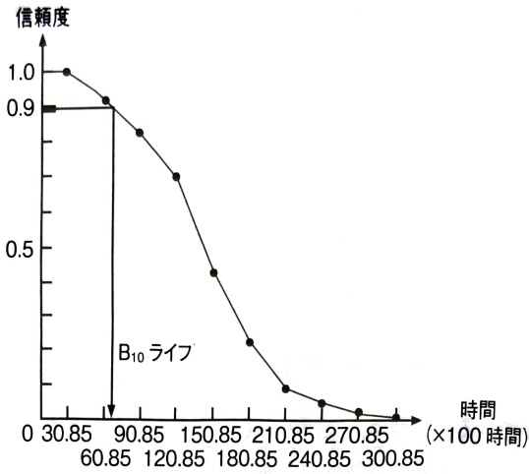
Figure 5.1.7 How to calculate $ B_{10} $ life from reliability
$$ B_{10} Life =60.85+\frac{0.942-0.900}{0.942-0.814}\times(90.85-60.85)=6,101(hours) $$
becomes.
[B_{10} Theoretical explanation and definition of life]
B_{10} Since the reliability in life is 90%,
$$ R(\mathrm{B}_{10}\mathrm{ Life })=0.90\quad\leftrightarrow\quad\mathrm{B}_{10}\mathrm{ Life }=R^{-1}(0.90) $$
becomes.
[B_{10} life in normal distribution]
The B₁₀ life of a normal distribution N(μ, σ²) with mean or MTTF μ and variance σ² is:
As shown in Figure 5.1.8, it is also the lower 10% point.
The value of B_{10} life is determined by standardizing the time until failure T as follows:
$$ X=\frac{T-mean}{standard deviation}=\frac{X-\mu}{\sigma} $$
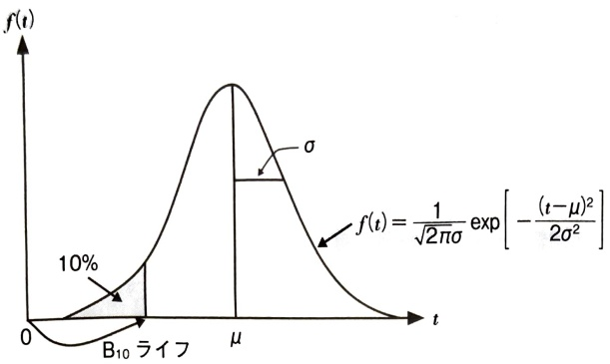
Figure 5.1.8 Normal distribution density function and $ B_{10} $ life
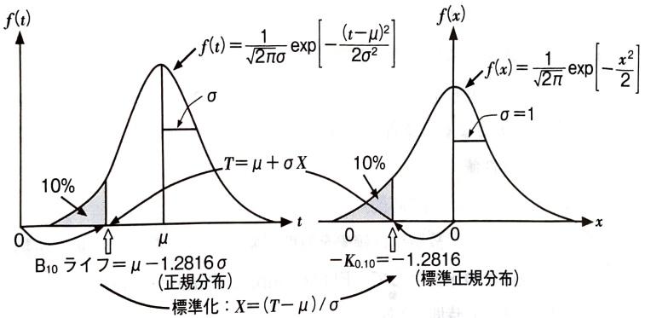
Figure 5.1.9 How to find $ B_{10} $ life from reliability (for normal distribution)
Then, it can be found using the fact that X has a standard normal distribution. In other words, the B₁₀ life of the standard normal distribution is -1.2816 as shown in Figure 5.1.9, so by inversely transforming this and returning it to the value of T,
$$ \mathrm{B}_{10} life =\mu-1.2816\sigma $$
becomes.
As can be seen from the B_{10} life of the normal distribution. The mean time to failure MTTF is the same.
Even if there is, if the variance is large, the probability that it will fail earlier than the average will increase, and the B_{10} life will approach the origin and its value will become smaller. B_{10}Life is a characteristic value that gives weight to events that fail early to represent the population. This shows that this is in line with the idea of ​​limit value guarantee.

2) Evaluation scale focusing on the number of failures
When evaluating durability by focusing on the number of failures within a certain period of time, the basis is the failure rate, which means the probability of failure per unit time. Let's use Example 5.1.1 to explain the concept of failure rate when repairs are not performed even if a failure occurs. The definition of the failure rate when a product is repaired and used again in the event of a failure is explained in Section 6.4 (2).

[How to find failure rate from histogram]
The number of samples in which a failure is observed in class i is the frequency $ f_i $. Therefore, the conditional probability that a sample that has not failed until the time of the lower boundary value $ T_{i-1} $ of class i will fail in class i is $ f_i/n_i $. The characteristic value where the conditional failure probability $ f_i/n_i $ is replaced by the class width h per unit time,
$$ \lambda_{i}=(f_{i}/n_{i})/h\quad(1/ hour ) $$
is called the (average) failure rate. Since the failure rate is the probability divided by time, its unit is the reciprocal of time. FIT (Failure in Time) is sometimes used as a unit of failure rate, and 1FIT=1 (1/10⁹ time).
From the histogram in Figure 5.1.3, the conditional failure probability $ f_i/n_i $ and failure rate are determined as shown in Table 5.1.5.
A graph of the failure rate is shown in Figure 5.1.10. This failure rate graph shows a pattern that increases over time, indicating that the failure rate tends to increase over time.
Table 5.1.5 Failure rate determined from histogram
number number | Class boundary value $ T_{i-1}\sim T_{i-1} $ | Frequency $ f_{i} $ | Remaining number $ n_{i} $ | Conditional failure probability $ f_{i}/n_{i} $ | Failure rate $ (1/10^{f}) $ $ (f/n_{i})/h $
1 | 30.85～60.85 | 4 | 70 | 0.057 | 0.19
2 | 60.85～90.85 | 9 | 66 | 0.136 | 0.45
3 | 90.85～120.85 | 10 | 57 | 0.175 | 0.58
4 | 120.85～150.85 | 18 | 47 | 0.383 | 1.27
5 | 150.85～180.85 | 13 | 29 | 0.448 | 1.49
6 | 180.85～210.85 | 7 | 16 | 0.438 | 1.46
7 | 210.85～240.85 | 5 | 9 | 0.556 | 1.85
8 | 240.85～270.85 | 3 | 4 | 0.75 | 2.50
9 | 270.85～300.85 | 1 | 1 | 1 | 3.33
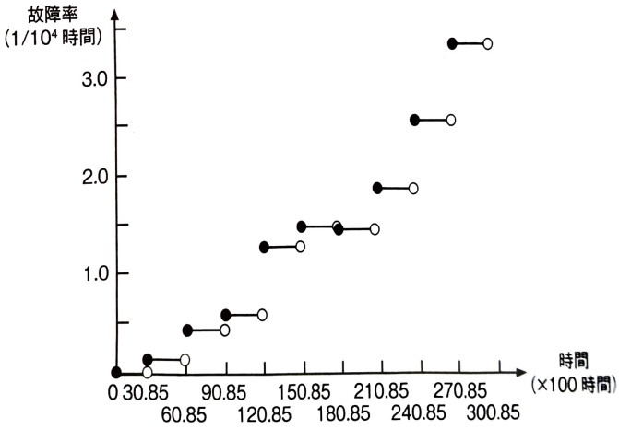
Figure 5.1.10 Failure rate graph

(3) Failure pattern
The idea of ​​failure patterns is to clarify the characteristics of durability by focusing on changes in failure rates over time. Knowledge of failure patterns is important when considering and applying measures to reduce the occurrence of failures.

1) Three failure patterns
Focusing on the change in failure rate over time, it can be divided into three categories: decreasing (non-increasing), constant, and increasing (non-decreasing), as shown in Figure 5.1.11. Each is called as follows.
• Early failure type: A failure pattern in which the failure rate decreases over time, also known as the DFR (Decreasing Failure Rate) type.
- Random failure type: A failure pattern where the failure rate is constant and does not change over time; also known as the CFR (Constant Failure Rate) type.
・Wear-out failure type: A failure pattern in which the failure rate increases over time, also known as the IFR (Increasing Failure Rate) type.
With random failure types, it is literally impossible to detect the signs of failure, so it is impossible to reduce failures through operation during use. To reduce failures, it is essential to take design measures that ensure an appropriate margin for functional limits. In the case of failure patterns of friction failure type or early failure type, the characteristics of the mechanism leading to the failure are investigated.
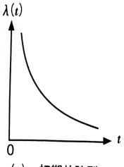
(a) Early failure type
(DFR (Decreasing Failure Rate) type)
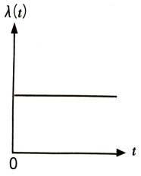
(b) Random failure type
(CFR (Constant Failure Rate) type)
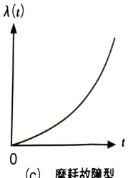
(c) Brake failure type
(IFR (Increasing Failure Rate) type)
Figure 5.1.11 Failure pattern
By understanding and responding appropriately, it is possible to prevent failures from occurring, as described below.

2) Failure patterns and failure countermeasures

① Measures against wear-out failure (IFR) type failures
When time plays an important role before change manifests itself in the form of a failure, it results in a wear-out failure pattern. In terms of failure mechanism, failure does not occur with a single stress action, such as fatigue failure, but as stress is continuously applied, material deterioration gradually permeates, and failure can eventually be recognized in the form of failure.
If local changes can be detected before failure occurs and deterioration can be restored through replacement, chain events and effects caused by failure can be alleviated. By measuring changes and substitute characteristics that are correlated with changes, failures can be prevented, as shown in Figure 5.1.12. It is in the case of wear-out failure patterns that failures can be prevented through inspection and testing.

[Example of measurement technology to detect changes over time]

(a) Example of transformer abnormality determination based on generated gas
In oil-immersed transformers, the insulating oil and insulating paper deteriorate due to overheating, discharge, and aging, and gas-in-oil analysis is used to determine whether or not internal abnormalities have occurred and to diagnose the deterioration of the insulating paper based on the amount and composition ratio of dissolved gas in the insulating oil. This takes advantage of the fact that gas generated by arcing, etc. increases as the dielectric strength decreases.
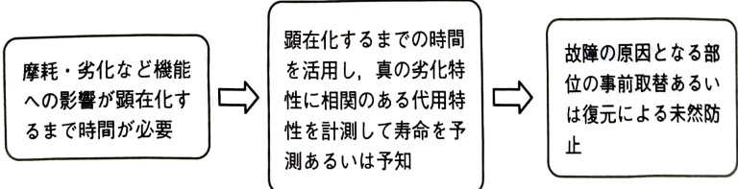
Figure 5.1.12 Countermeasures for wear-out type failures
Table 5.1.6 Relationship between abnormal phenomena and generated gas in oil-filled gas analysis of oil-immersed transformers
Factors causing gas in oil | H2 | CH4 | C2H6 | C2H4 | C2H2 | CO | CO2
overheating | insulation oil | low temperature | ○ | ◎ | ◎
Medium/high temperature | ○ | ○ |  | ◎
700℃ or more | ○ |  |  | ◎ | ◎
insulation paper |  |  |  |  |  | ◎ | ○
discharge | insulation oil | partial discharge | ◎ |  |  |  | ◎
arc discharge | ◎ |  |  | ◎ | ◎
insulation paper
aging | insulation oil | Oxygen rich | ○ | △ | ◎ |  |  |  | ○
low oxygen |  | △ | △ |  |  |  | ○
insulation paper |  |  |  |  |  | ○ | ◎
Importance ◎: Large ○: Medium △: Small
(Source) Electric Cooperative Research Group Report (1998): "Maintenance and Management of Oil-immersed Transformers". Electric Cooperative Research Group Volume 54 No. 5 (Part 1). p. 50. (Electric Cooperative Research Group.
Table 5.1.6 shows the relationship between abnormal phenomena and the main gases produced.

(b) Engine wear limit based on SOAP (Spectrometric Oil Analysis Procedure) method
Spectroscopic analysis of the types and amounts of metals contained in engine lubricating oil is used to estimate the locations and extent of wear. In other words, the oil collected from the engine is made to emit light using a spectrometer, and the metal elements are quantitatively analyzed from the spectrum and light intensity. If the analysis results show that an element exceeds a predetermined amount, the engine will be disassembled and inspected as necessary. This method is particularly effective for engines that consume little lubricant, such as jet engines.
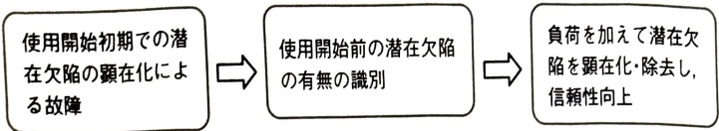
Figure 5.1.13 Early failure type failure countermeasures

② In case of initial failure (DFR) type
An early failure type is a failure pattern in which failures tend to occur in the early stages and become less likely to occur over time. If there is a defect, the load during use will cause the defect to expand in the early stages and manifest itself in the form of a failure.
In such failure patterns, screening technology to determine whether the product can withstand the load during use is the key to preventing failures, as shown in Figure 5.1.13.

[Example of measurement technology to detect early defects]

(a) Screening test for latent defects of soldering micro cracks by thermal cycle test
If there is a microscopic crack defect, when thermal stress is applied, large thermal stress will be generated in the cracked area due to stress concentration. By utilizing this principle, it is possible to apply a large thermal stress that exceeds the durability limit to a defective sample and enlarge minute cracks. Therefore, it is possible to identify the presence or absence of latent defects by measuring electrical characteristics. Screening tests can be performed by designing test conditions such that thermal stress is applied at a level that does not cause damage to healthy samples.

(b) Fastening screening test using random vibration aging
For assemblies that are fastened with bolts, if the initial tightening is insufficient, the fastening may loosen due to the load during use, generating excessive stress and causing damage. Random vibration aging is a method to discover whether loosening occurs by applying a vibration load with a random vibration amplitude or cycle time. compared to sine wave
is further replaced by per unit time. From this definition, the (instantaneous) failure rate $\lambda(t)$ at time $t$ can be expressed by replacing minute time $h$ with $\Delta t$ as follows:
$$ \begin{aligned}\lambda\left(t\right)&=\lim_{\Delta t\rightarrow0}\frac{1}{\Delta t}P\left\{t<T\leq t+\Delta t\left|T\right|>t,\ t\geq0\right\}\\&=\lim_{\Delta t\rightarrow0}\frac{1}{\Delta t}\cdot\frac{F\left(t+\Delta t\right)-F\left(t\right)}{R\left(t\right)}=\frac{f(t)}{R\left(t\right)}\end{aligned} $$
becomes. Furthermore, if we pay attention to $ R(t) = P(t < T) = \int_{t}^{\infty} f(x) dx $, we get $ f(t) = -\frac{dR(t)}{dt} $, so equation (5.1.6) becomes
$$ \lambda\left(t\right)=\frac{-\frac{dR\left(t\right)}{dt}}{R\left(t\right)}=-\frac{d\ln R\left(t\right)}{dt} $$
can be expressed as a differential equation. If we solve this differential equation with the initial condition that the reliability at time 0 is 1, we get
$$ R\left(t\right)=\exp\left\{-\int_{0}^{t}\lambda\left(x\right)dx\right\} $$
You can get the expression

5.2 Maintainability
The reliability of products that are used over long periods of time, such as durable consumer goods and production equipment, is determined not only by their durability but also by the ability to detect aging changes during use and operation through inspection and inspection, by restoring changed conditions, and by improving the product through collaboration between users and manufacturers (improvement maintenance) to make it less likely to break down.
If daily inspections such as refueling and retightening of production equipment are not performed properly,
Failures are likely to occur due to forced deterioration such as wear. Asking people about design, inspection, etc.
The malfunction of the production equipment caused by this is as follows:
・Inappropriate basic condition of equipment: Inappropriate standards for lubrication, retightening, etc.
- Inadequate maintenance of basic conditions: Standards such as refueling and retightening are not followed.
・Leaving a deteriorated state: Leaving a worn bearing or chucking unattended, etc.
·Design weaknesses: Occurrence of failures due to inappropriate equipment design
・Lack of skills: Lack of basic knowledge about pneumatics, hydraulics, drives, sequence control, etc. necessary for equipment inspection
can be given. In addition, natural deterioration may not be avoided even if the design and daily inspections are performed accurately.
In addition to understanding the structure of products and equipment and being involved in maintenance, students will gain an understanding of the actual state of maintenance, including accessibility during inspections and inspections during use and operation stages. Whether or not it is possible to grasp and share actual maintenance information in addition to basic functions during build-in and review at the design stage has a significant impact on reliability.

(1) Two types of conservation measures
There are two types of maintenance measures: corrective maintenance and preventive maintenance, as shown in Figure 5.2.1.
Corrective maintenance is the process of repairing and restoring a device to a usable condition after a failure occurs. Corrective maintenance consists of emergency maintenance, which involves performing corrective maintenance on equipment subject to preventive maintenance, and emergency maintenance.
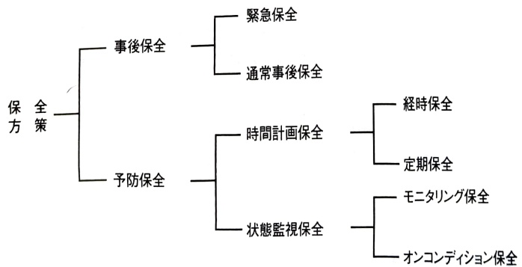
Figure 5.2.1 Classification of conservation measures
It can be divided into other types of normal follow-up maintenance.
When failures lead to the loss of important functions, which in turn lead to greater damage and safety issues, emphasis must be placed on preventive maintenance activities such as inspections, inspections, and advance replacements to prevent failures from occurring.
Preventive maintenance can be divided into two types: time-planned maintenance, which replaces parts before failure based on time information, and condition-monitored maintenance, which makes judgments based on changes over time. Time-scheduled maintenance includes chronological maintenance based on actual usage and operating hours, and periodic maintenance based on calendar time. Condition monitoring maintenance is divided into monitoring maintenance and on-condition maintenance, depending on whether the object to be monitored is left running or stopped.

(2) Maintainability evaluation scale

1) Corrective maintenance evaluation scale
A scale for quantitatively evaluating corrective maintenance can be defined in the same way as reliability of durability, considering the repair time required to make the product usable again after a failure. However, since it is desirable that the repair time be short, the maintenance degree corresponding to the reliability is the probability that the repair will be completed within a given time.
Repair time is the time it takes to repair and restore the system after a failure occurs. This includes the time it takes to investigate the cause of the failure and the time it takes to order parts that need to be replaced to restore functionality.
The probability that repairs can be completed and restored to a usable state within a given time is called the degree of integrity. In other words, if the repair time is W, and the degree of maintenance at a given time w is G(w), then
$$ G(w)=P(W\leq w) $$
It is. The average repair time is the average repair time, and is called MTTR (Mean Time To Repair).

2) Preventive maintenance and maintainability design
For preventive maintenance, unlike corrective maintenance, there is no quantitative evaluation scale;
The main method is review using lists. In order to increase the efficiency and effectiveness of condition monitoring and cause investigation, it is important to have maintainability design that takes maintainability into consideration at the design stage, as well as the technology necessary for maintenance. The following are the key points to check to evaluate maintainability design.

① Design consideration for accessibility
In order to facilitate inspections and inspections during use, it is important to centralize the target area and consider the structure and layout so that it can be easily seen from the outside, that is, accessibility. Examples of efforts to improve accessibility in production equipment and line design are shown in Figure 5.2.2.
If the mechanical equipment is shielded with a steel plate, etc., it will be difficult to see it from the outside, so use transparent panels. A CCD (Charge Coupled Device Image Sensor) camera is installed inside the device so that the operating status of important parts can be visually seen from the outside. By keeping the height below a certain level so as not to obstruct the field of view, and by making it easy to see machines and delayed processes, it will be easier for operators to detect changes. "Visualization" that takes accessibility into account is the basis of digital manufacturing, which utilizes production technology know-how in the form of guidelines. Machines in factories also respond to human movements.

(a) Making the shielding part transparent
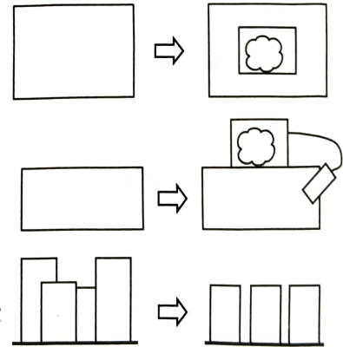

(b) Utilization of monitoring
(c) Unified line equipment height
Consideration for layout, etc.
Figure 5.2.2 Method of improving equipment accessibility
By opening up everything you feel, you can increase your awareness of change.

② Design considerations for failure diagnosis technology
Fault diagnosis involves acquiring signals of changes over time, and to improve accuracy it is essential to consider noise reduction not only during operation but also during design. When diagnosing vibration changes due to shaft runout using sound, it is effective to reduce noise if the housing design allows the listening rod to approach the source of the change.
Specific issues and countermeasures when using vibration analysis to obtain secular changes due to wear and other factors in the bearings of rotating equipment include:
- Noise: Due to noise entering from the input cable, vibrations may be detected even when the equipment is not operating. Please note that the cable may also serve as an antenna.
・Measurement timing: Since vibration changes depending on operating conditions, one method is to measure at the operating state where vibration is at its maximum (e.g., measuring vibration at maximum pump discharge or maximum line pressure).
・Sensor falling off: If the base of the vibration sensor shell is weak, the sensor itself will fail, not the equipment being measured.
- Power supply: Direct input from a 100 volt power source may add wrap-around noise, so take measures to reduce noise by inputting power from a sequencer. Operational know-how of fault diagnosis technology is valuable as an information source for improving maintainability design.

③ Design consideration for modularization
In order to reduce the need for service stoppages due to inspections and inspections, it is essential to create modules (cartridges) that allow for easy installation and removal of target parts. If users can make replacements themselves, they can build relationships with customers even when they are using the product through the purchase of spare parts and replacement parts, which is also effective in reducing lost business opportunities.

④ Design considerations for common parts
By examining related products and equipment cross-sectionally during the development stage, identifying the range of consumables and regularly replaced parts that can be shared, and centrally managing replacement parts, it is possible to reduce the inventory of spare parts in case of failure. In other words, if the variance representing the fluctuation in demand for spare parts due to a failure at each location is σ², then the safety margin when spare parts are managed at n locations is proportional to n, and the safety margin when spare parts are managed centrally at one location is proportional to √nσ, so centralized management reduces the inventory required to secure the safety margin. By standardizing parts and centrally managing spare parts, it is possible to rationally deal with opportunity losses caused by production failures due to equipment failures, etc.

(3) Comprehensive evaluation of durability and maintainability and integrity
If the product can be repaired even if it breaks down, consider not only durability to prevent it from breaking down, but also maintainability to see if it can be easily repaired. In other words, even if a device breaks down, there are cases where it is good to be able to repair it immediately and make it usable again. It is important to be able to use the product when you want to use it, and this is called availability, and is one of the measures that comprehensively evaluates durability and maintainability. A detailed analysis of availability is described in section 64 (1), Availability of systems with repair systems.
Here, we will explain the concept of Overall Equipment Efficiency, which is used for equipment management evaluation of production equipment. Overall equipment efficiency is used as an index to measure how efficiently and effectively equipment is used in lot production and batch production.

1) Concept of overall equipment efficiency
Overall equipment efficiency is defined in relation to losses that impede equipment efficiency. The time required to process the required number of good workpieces using a certain piece of equipment is called load time. The estimated (standardized) time required to machine one workpiece is called the standard cycle time. The load time is shown in Figure 5.2.3. Value operating time, which is the product of standard cycle time and required quantity, and load time and value operating time.
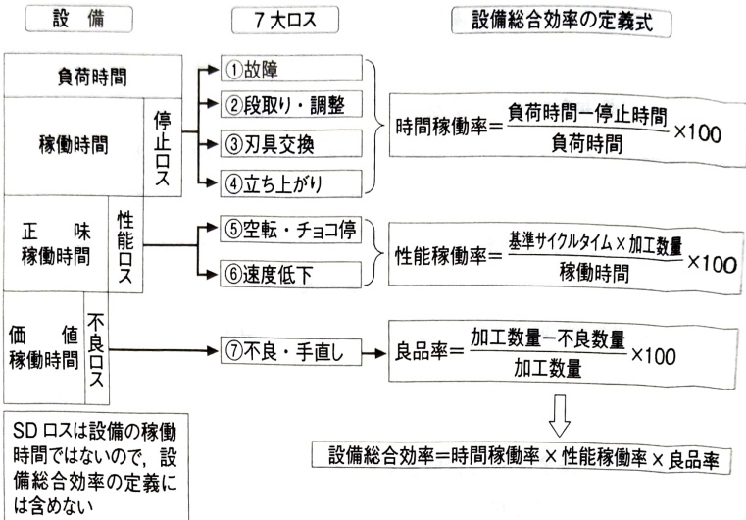
Figure 5.2.3 Concept of overall equipment efficiency
The difference in time can be reduced to 2 minutes. Overall equipment efficiency is an index that takes load time as the denominator and value operating time as the numerator.
$$ Overall equipment efficiency = Tsukuda operating time / load time $$
It is defined as If this value is close to 100%, it means that equipment loss is low and efficiency is high.
By further dividing losses into stoppage losses, performance losses, and defective losses, overall equipment efficiency can be broken down into three parts, and the factors that impede efficiency can be stratified and quantitatively determined.
$$ \begin{aligned} Load time &= Operating time + Stop time \\&= Net operating time + Performance time + Stop time \\&= 俪值 working time + Performance time + Stop time + Defective time \end{aligned} $$
By decomposing this, the overall equipment efficiency is
$$ \begin{aligned}& Overall equipment efficiency = hourly utilization rate \times performance utilization rate \times good product rate \\& where .\\ \end{aligned} $$
$$ Hourly operation rate = (Load time - Stop time)/Load time $$
$$ Performance utilization rate = (standard cycle time \times machining quantity)\nearrow operating time $$
$$ Good product rate = (Processing quantity - Defective quantity)\nearrow Processing quantity $$
It can be decomposed into the product of three indicators. Empirically, the best practice for the three indicators is that the time utilization rate is 90% or more, the performance utilization rate is 95% or more, the quality product rate is 99% or more, and the product of these indicators, the overall equipment efficiency, is 85% or more.

2) Improving overall equipment efficiency and reliability
Hourly operating rate and performance operating rate are directly related to the durability and maintainability of equipment. To improve this, it is necessary to reduce stoppage loss and performance loss. These losses are, respectively,
$$ Stop port = failure port + setup \cdot adjustment port + tool replacement port + rising port $$
$$ Performance mouth = idling \cdot chocolate stop mouth + speed reduction mouth $$

It can be decomposed into
If there is no need to break down or change tools while the equipment is in operation, failures and tool replacement losses will be zero, and if maintenance and management over time is properly carried out, speed reduction losses will be zero. Proper equipment maintenance can improve productivity and quality.
Overall equipment efficiency is generally around 40 to 60%, and if you increase this to 80% or more, you can produce 1.5 to 2 times more with existing equipment, and conversely, if the production volume remains constant, you can produce with 1/2 to 2/3 as much equipment.
In order to further improve the overall efficiency of equipment, we will install good equipment from the equipment development stage. One way to do this is to systematically organize and utilize information such as equipment failures during use, as shown in Figure 16.1.5 (p.858). Information organized so that it can be used to improve reliability and maintainability, which are elements other than the basic functions of equipment, is called MP (Maintenance Prevention) information.
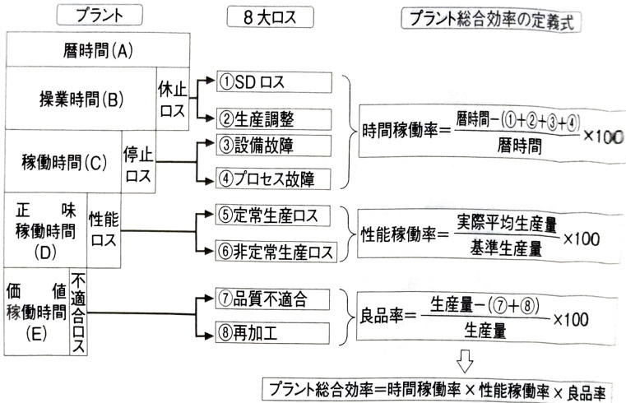
Figure 5.2.4 Concept of overall plant efficiency

3) Concept of overall plant efficiency
Just focusing on individual equipment may not be enough. When focusing on the flow of workpieces, such as moving workpieces through multiple pieces of equipment for cutting and polishing during the machining process, it is also necessary to evaluate multiple pieces of equipment together. In addition, in chemical reaction processes, reactions and by-products from reactions are processed continuously using multiple facilities. The concept of overall plant efficiency shown in Figure 5.2.4 is suitable when targeting a line or plant consisting of multiple devices or facilities rather than a single device or facility.

5.3 Human reliability
The third element of reliability is human reliability, which is related to "ease of use", which is important for users of products and systems. In order to ensure safety and security by considering the diverse ways in which people use products, it is necessary to reduce human errors and take technical measures in design to prevent errors from becoming fatal.

(1) Three interfaces
Problems often occur due to the interface between the user and the product. We take a bird's-eye view of the state of products and equipment as a system of humans and products, including users. Consider the user interface.
Conventionally, as shown in Figure 5.3.1, design considerations have been made to solve technical issues from an ergonomic perspective, focusing on visibility and operability issues. These are respectively called the interface between the sensory organs and the display system, and the interface between the motor organs and the operation system.
Furthermore, as shown in Figure 1.6.4, automation is progressing to take in information using the product's own sensing function, process it using control logic in a controller, and transmit the results to actuators to control the state of products and systems. In other words, the system itself has cognitive functions such as perception and memory. Therefore, we also consider the interface between the cognitive functions of humans and systems (referred to as the cognitive interface), and analyze the information processing characteristics of humans and computers respectively.
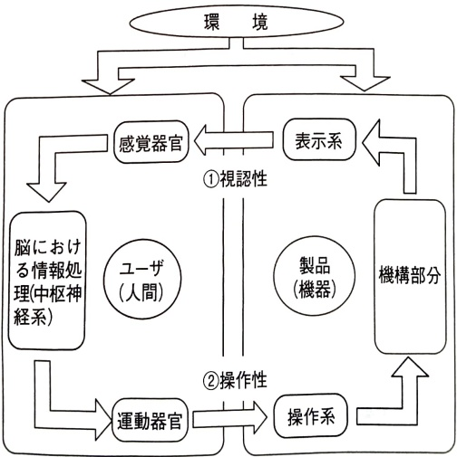
Figure 5.3.1 User-product interface
Based on this, we will discuss the concept of designing an interface and make it concrete.

(2) Interface between sensory and motor organs
The interface between sensory organs and motor organs is affected by whether the size, color, shape, and layout of the numbers on instruments are considered to be easy to read, and whether the shape, strength, rigidity, and arrangement of pedals and switches in the operating system are considered to make them easy for the user to operate. Therefore, human functions are measured and analyzed by converting them into physical quantities such as visual acuity and grip strength, and the obtained knowledge is reflected in the design of display and operation systems. These basic data are essential when modeling and computer simulation, as indicated by the term digital human.
In 2006, there were many accidents in which children's fingers were cut off due to the wide opening of the shredder, and children got their fingers stuck together with the paper. Let's think about this based on the concept of safe distance at the opening. According to EN295:1992, which stipulates the safe distance of openings for users aged 15 and over, the depth of openings is 5 mm or less. If you are targeting younger users, you may need to narrow it down even further. The recommended value by the National Consumer Affairs Center of Japan, based on the results of collecting and analyzing accident information, is 3 mm or less. Additionally, if the opening is made of resin, it may deform and become larger, so it is necessary to understand the relationship between the force and the amount of deformation to ensure safety.

(3) Cognitive interface

1) Cognitive interface in automation
For products that incorporate automation using electronic control units (ECUs), it is necessary to consider cognitive interfaces that take into account the differences in information processing between humans and computers. For example, as shown in Figure 5.3.2, when it comes to cooperation between automation and humans, there are problems with errors caused by a combination of human familiarity and automation technology, related to algorithms that prioritize and process inputs and changes in the division of roles between humans and computers. This problem solving is also related to the design concept and usage environment conditions, and the optimal solution is uniquely determined.
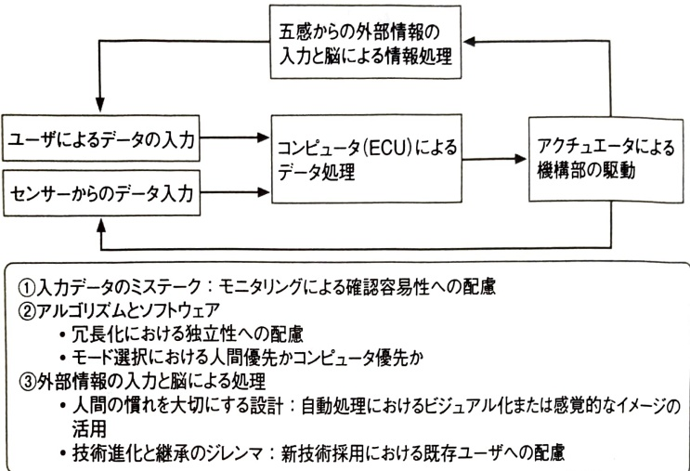
Figure 5.3.2 Issues in information processing by humans and sensing
Table 5.3.1 Comparison of FBW (fly-by-wire) design philosophy between B777 and A320
 | B777 | A320
Role sharing between people and computers | A system is adopted in which the control stick becomes heavier when the control stick is likely to exceed its normal limits.In the end, the pilot is stronger than the computer. | No matter how much you keep tilting the control stick, the computer automatically adjusts the rudder to prevent the aircraft from tipping over 67 degrees.
Human familiarity and adoption of automation technology | The control stick moves in accordance with the rudder even on autopilot.It is better to convey a visual image. | When on autopilot, the control stick is stationary.
When flying horizontally, increasing speed increases lift and raises the altitude, so it is necessary to push the control stick to lower the aircraft to maintain the same altitude. | Even if you increase speed while flying level, the computer's automatic adjustment function maintains level flight.
When an airplane lands, the rear of the airplane receives a stronger force from below (ground effect), so the nose tends to dip slightly. Consideration has been given to how pilots who are used to flying conventional airplanes will operate the airplane. | It is well-balanced, so the nose does not drop.When landing, the pilot tends to pull back on the control stick, so the computer automatically controls the nose to lower slightly at a certain altitude.
This can be understood by looking at the comparison of design concepts for Boeing's B777 and Airbus' A320 shown in Table 5.3.1.It is difficult to decide whether it is better to leave the final judgment to humans or to computers, as it depends on the situation in which the problem occurs.

2) Difficulties in dividing roles between humans and computers in automation
The crash of a China Airlines Airbus plane at Nagoya Airport in May 1995 reflects the difficulty of separating automation and human roles. One of the purposes of automation is to reduce human error due to misuse or operation errors. However, it is difficult to automate everything, and in the end we have to rely on humans. In order to expect people to make accurate decisions, the prerequisites for being able to accurately judge the surrounding situation must be met.

The circumstances of the accident are as follows.
・The co-pilot unconsciously hooked the re-landing lever, resulting in the aircraft entering re-landing mode and the computer lowering the horizontal stabilizer and raising the nose of the aircraft.
・However, since the aircraft continued to land by lowering the nose by manual operation of the elevator, automatic control by the computer functioned to cancel the nose-lowering.

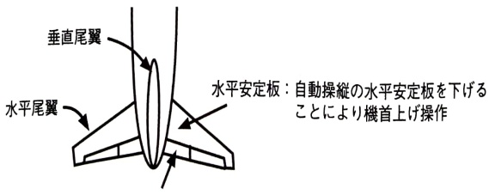
Elevator: The pilot manually lowers the elevator to lower the nose of the aircraft.
Figure 5.3.3 Airplane accident thought to be related to cognitive interfaces
• As a result, the horizontal stabilizer became ``inverted'' as shown in Figure 5.3.3, and the aircraft lost its balance, causing the nose to rise significantly, engine output to increase, and the aircraft's attitude to collapse.
Unknowingly switching the mode of the automatic landing system caused a discrepancy in the cognitive interface between humans and computers, sending conflicting instructions to the aircraft, which caused the aircraft to lose its attitude and cause the crash. Because there are many airports in Europe that are prone to fog, the aircraft is designed so that changing from automatic to manual landing at low altitudes with poor visibility cannot be done by operating the control stick alone. The problem of human-computer collisions may be solved by switching the control stick from automatic to manual control at low altitudes to make landing changes. However, new problems may arise if the aircraft is forced to land manually due to poor visibility during landing.

(4) Reducing human errors with a focus on communication

1) Characteristics of human information processing
In products that incorporate automation, as shown in Figure 5.3.4, sensors acquire information about vehicle speed, temperature, and other conditions, convert this information into signals such as voltage, and send the signals to an electronic control unit in which control logic is written. When input signals are processed based on the control logic, output signals are sent to actuators such as solenoid valves to bring the state closer to the target, and information about the difference between the target and the actual state is fed back for control. In humans, sensors include sensory organs such as vision and hearing, and electrical organs.
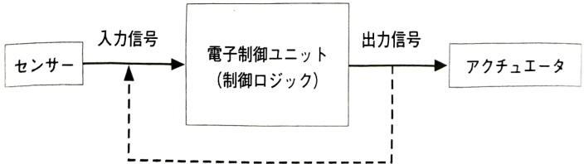
Figure 5.3.4 Flow of electronic information processing
The child control unit is the brain. Actuators correspond to moving organs such as hands and feet.
Electronic information processing by computers has been incorporated into many products used on a daily basis. For example, if the lid of an automatic washing machine is open, washing may be possible, but the dehydration function will not work. A sensor detects and acquires information on whether the lid is open or not, and controls so that power to rotate the motor is not supplied unless a signal indicating that the lid is closed is sent. With automation technology, once a switch is turned on, a series of operations are performed without the need for any human instructions, as the computer sequentially instructs the computer according to a program.
Humans are able to transmit a variety of information to their brains through their sense organs, and the processing procedures also vary from time to time. On the other hand, the information that is input into the computer is determined in advance, and the processing procedures are also fixed. In the case of people, even if information is conveyed, it may or may not be transmitted. In order to reliably convey information to users to maintain or ensure safety in situations that impede safety, we need to focus on how humans process information and consider the nature of the human-computer interface.This is important not only for safety, but also for making it easy to use the basic functions of the product.
On the other hand, as mentioned in the case of the China Airlines crash, there are cases where automation technology is involved in the cause of safety-related accidents. With the advancement of electronic control technology using computers, products themselves have come to have cognitive functions such as perception and learning, and cognitive interfaces with people have become important. When considering cognitive interfaces, it is important to note that information processing by humans and computers is not based on the same principle, but is different.
For example, the brain has the following information processing characteristics.

・The brain is a computer that works based on motivation: People analyze and judge whether information that comes from the outside through their sense organs is of value to them or not, and control brain activity based on value information. When the brain recognizes that external information has value, brain activity increases, and the information processing circuits for this purpose develop. Therefore, the standards of value for information may not be the same on the side transmitting and receiving information.
The information you want to convey may not be conveyed.
・Formation of value standards in the brain: We genetically have a desire to maintain our bodies (physiological needs) and a desire to have our existence accepted (acceptance needs), and based on these, we form value standards through experience.
• Changing your value standards: You will be forced to change your values ​​until you are cornered to the point where there is nothing you can do about it anymore, and it will be difficult for you to change yourself.
The failsafe concept is an important method of controlling safety. This method effectively incorporates the characteristics of the brain's information processing and human learning through trial and error. If you use something according to your own way of thinking and it doesn't work out, you will be in trouble. When they are in trouble, they try to get out of that situation by learning to incorporate new information from outside, such as by reading manuals or asking people. In other words, by changing the way you think, you can learn how to use it appropriately and solve difficulties. This kind of interface is effective in coordinating the ideas of creators and users.
To consider the nature of cognitive interfaces, we must consider humans as information processing systems and understand how the information taken in by the human sensory system is integrated with the experience and knowledge that has been accumulated up to now. Research in this direction is being actively conducted in the field of cognitive psychology, and the results of this research are having a major impact on research in artificial intelligence.
Considering the characteristics of information processing in the human brain, the important points of the cognitive interface can be summarized into three points as follows.

① How to flow information based on the human memory system
The amount of information that the sensory organs can process is infinite, but only for a moment, and as shown in Figure 5.3.5, this is transferred to short-term memory, which requires rehearsal when activated, and it is said that the amount of information that can be processed at one time is limited to 3 bits (sometimes referred to as the magic number seven). It is necessary to send a lot of information to the sense organs.
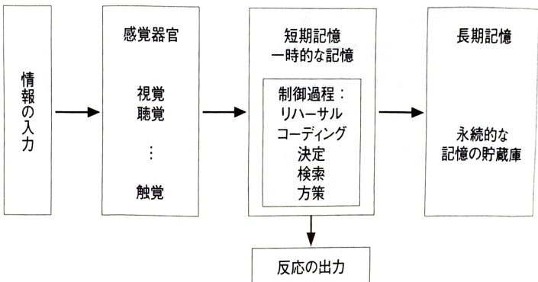
Figure 5.3.5 Macro model of human cognitive process
When necessary, it is necessary to take measures such as creating a hierarchy so that the user can make selections.

② Visualization of processing process
Users feel anxious, and they feel relieved when they can see the processing process. To this end, it is important to return a response within an appropriate functional response time.

③ Aligning the mental models of creators and users
A mental model is ``symbols or expressions that are formed in a user's own head to save time and energy in recognizing and making decisions in situations that are too complex to act based solely on information obtained through observation,'' and have the same meaning as fixed ideas. Mental models are incomplete, unstable, have ambiguous model boundaries, are formed based on incomplete knowledge, and are poor, so they may lead to misuse due to assumptions. The basis of human learning is trial and error, and we will devise design considerations and descriptions of displays and instruction manuals that will facilitate this learning by coordinating the ideas of users and designers.
2) Force, explanation, guidance and interface

① Consideration for safety and protection systems: From the burden of duty of care on users to solutions through technology
Failure to follow established procedures is called an error, but as shown in Figure 5.3.6, the meaning is different from misuse, which is most often used in product liability defenses. For example, if a machine has a safety guard on it, but it gets in the way when cleaning, so you remove it and get injured. Judging from court cases in the United States, a defense of misuse by the manufacturer does not necessarily hold true. In other words, if the product was removed because it would get in the way of cleaning, the manufacturer could have reasonably foreseen how it would be used, and a requirement for a successful defense is to be able to properly explain from a technical and economic perspective how to prevent errors through design methods such as interlocks, and how to communicate danger through warnings and displays.

② User interface
If you are deciding on a product's interface to suit people, the term machine interface may be appropriate. However, following common usage, we will use the term user interface here. The idea of ​​building an interface is
• Coercion
· Description
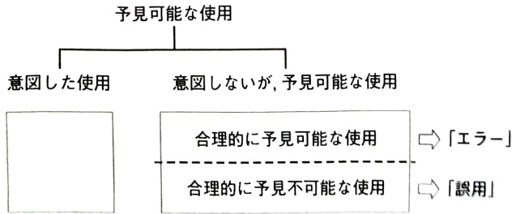
Figure 5.3.6 Relationship between foreseeable use and errors and misuse

·Induction
It is easy to understand if you classify them into three categories.
Coercion literally means forcing the user to use a product in a certain way. For example, the safety switch attached to the door of a safety guard is turned off when the door is open, and the equipment cannot be operated unless the door is closed. The concept of enforcement is often used to physically move people away from a hazard to prevent a fatal problem from occurring.
Explanation is a method of notifying the existence of the hazard and the actions to be taken when it is not possible to technically eliminate or avoid the hazard, using methods such as warning signs, such as ``Do not approach due to the risk of electric shock.'' In order to achieve safety, such methods of enforcement and explanation are also necessary.
Even if a safety guard is installed to prevent people from touching the rotating parts and injuring themselves, there are cases where someone accidentally injures themselves by removing this guard. The most common reasons for removing it are that it gets in the way and that it is difficult to use. If a safety feature interferes with the basic functions of a product or device, the safety feature may be turned off. It is necessary to consider an interface that is compatible with both functions. In other words, it is the construction of an interface that guides users to actively use the product in a safe manner.
For example, if it is necessary to remove the safety guard each time you clean or inspect the equipment, you may end up removing it even though you should be using it with the safety guard attached. Therefore, designs should be designed to allow for cleaning without having to be removed, design considerations should be made to reduce the frequency of cleaning, and the provision of transparent parts on the guard to facilitate inspection. This will encourage users to discover the existence of hazards on their own, and will also guide them toward taking safe actions on their own.

The user is the person who practices safe usage, and an interface that guides them to safe usage is constructed. One method of guidance is trial-and-error learning, and since this is learning that tolerates errors, error recovery is required to prevent harm even if the user uses the product incorrectly. representative
One method is the fail-safe concept.

3) Humans and machines are different: Comparison of characteristics between humans and machines

① Differences in principles and methods of performing functions between humans and machines
It is said that people began to use tools in search of a more comfortable life. With the invention of the steam engine, the use of tools such as copperware and ironware evolved to include power sources, and their application to industry led to the Industrial Revolution. Furthermore, electronic control technology that uses computers as the core of control is now being used in many areas of daily life. Cars are equipped with more than 30 electronic control units, a type of computer that performs electronic control. Such mechanization and automation have been devised and put into practical use for humans. However, the principles and methods used to perform necessary functions are often different between humans and machines. Cars move by rotating their wheels, but humans walk on two legs, raising their legs alternately and moving forward, making this system convenient for moving not only on paved roads but also on non-flat surfaces such as fields.
In this way, humans and machines often perform the same functions but have different mechanisms. Furthermore, a more fundamental difference is that machines are artificial objects created by humans for the purpose of performing a specific function. The creator may have a good understanding of the function itself, its operating principles, and its limitations. However, it is common for people who use devices, that is, users, to use them without fully understanding the operating principles (black box), as can be easily understood when considering information devices such as personal computers.
When humans perform a certain function, the range of application is extremely flexible and wide compared to machines, and they have an excellent ability to limit and respond to infinite possibilities. It is thought that the reason why people with limited cognitive abilities are able to cope with an external environment that can have infinite variety is because they have a ``frame of reference'' such as a ``scheme (cognitive framework)'' or ``paradigm,'' which allows them to filter and incorporate information from the outside. Changes in the environment can be achieved by changing filters and paradigms.
We are making it possible to respond to changes. Therefore, they are capable of adapting to various environmental changes (known as dynamic capabilities), and are different from machines that have a limited scope of application (so-called excellent static capabilities).
A good cognitive interface can be constructed by appropriately utilizing people's dynamic abilities. In order to respond to a wide range of adaptation with limited recognition ability, learning is required to rearrange filters in response to environmental changes. Even if you do not understand the operating principles of a machine, you can learn how to use it according to your own intended use. Furthermore, it would be even better if the interface was constructed in such a way that the operating principle itself can be understood through learning.

② Comparison of characteristics of humans and machines
Humans perform such cognitive information processing to respond to diversity and change in the external world. During this process, learning is performed to increase new knowledge, which is added to the memory structure of previously accumulated knowledge, and three types of operations are performed: reorganization and synchronization. In the process of knowledge acquisition, preexisting memory schemes play an important role. If the new knowledge is a basic memory scheme, it is an addition; if the basic memory scheme does not exist, the memory scheme is reconstructed, and this reconstruction often causes conflicts between the schemes. Therefore, coordination and synchronization are required. A major and powerful characteristic of humans is the ability and tendency to build models of the world, predict events, and anticipate their own experiences. This ability is even more important in perception, where expectations and context play important roles, where conceptually guided processing plays a fundamental role.
Table 5.3.2 summarizes the basic differences between humans and machines, taking into account the abilities that humans have. What is important in this table is the item of applicability. Whereas machines have a limited range of application in advance, humans can change the range of application. The mechanism by which people change the scope of application is being actively researched in the field of cognitive psychology, including the reorganization of memory schemas. Therefore
Table 5.3.2 Basic differences between humans and machines
 | people | machine
Reliability | Generally low, partially measurable | Generally high, measurable
Operating principle | Causal but non-deterministic | causal and deterministic
Design | Explicit and difficult to formulate | Explicit and often formalizable
Model availability | less, descriptive | many, prescriptive and descriptive
Applicability | Can be used in various cases | rare and limited range
failure model | descriptive and unpredictable | Usually predictable (slow deterioration)
Capacity | fluctuate up and down | Constant or gradually decreasing
(Source) Hallangel (1993): Human Reliability Analysis Context and Control, p.101, Academic Press.
The approach of analyzing agglomerated phenomena by parameterizing them into intermediate physical quantities such as stress and strength is inevitably quite limited compared to the case of machines. The limitations of analysis tools make it difficult to consider the interface that machines should have with humans.

4) How to respond to usage patterns in product design
Based on the dichotomy of user usage patterns
① Intended usage pattern
② Unintended but reasonably foreseeable usage pattern
② -1 Use in failure condition
② -2 Use in situations other than failure conditions
Table 5.3.3 shows how the three designs address product safety.
The design of human-system interfaces is moving toward user-interface-driven design, which is a way of thinking that first clarifies the entire system function and then optimizes the division of roles between people and the system with a focus on customers and users. former automatic
Table 5.3.3 Response to product safety based on user usage pattern
Usage style design | Intended usage | Unintended but reasonably foreseeable forms of use
Use in fault conditions | Use outside of fault conditions
User interface design | Complementarity of function and reliability design and its verification; Operational function principle diagram (parameterization and illustration of information, material and energy flow); Division of task roles; Information on structure, shape, and stress during operation. | Feedback of information to users (warning of fault conditions) | Support for error recovery (safety functions) such as trial and error learning support
software design | Mitigation of effects by interrupting the chain (safety function)
hardware design
The car's capretor, which mixes gasoline and air, had to be adjusted according to driving conditions such as weather and mountain roads, and drivers had to know the mechanics of the car. There were limits to hardware adjustments, and if the limits were exceeded, users had to make adjustments themselves. In other words, it was accepted that ``cars have quirks,'' and it was the user's role to make full use of them. However, with the advancement of electronic technology, ``If the brakes are too strong on a wet road, the ABS (Antilock Break System) is activated, instantly releasing the brakes and allowing the tires to grip the road.'' Depending on how you release the brakes, you may feel that the brakes are not very effective. Drivers may feel uneasy depending on their ``habits of effectiveness,'' so it is important to consider ways to create a user interface that does not make drivers feel uneasy.
The idea that users adapt to hardware and software is to compensate for tasks that users themselves cannot perform with hardware and software. The design is tailored to the user's usage, including the variety of usage conditions and usage environment conditions. Define users, imagine what kind of usage patterns are possible, clarify the entire task domain, and design the division of roles between users and hardware and software. As shown in Figure 5.3.7, the priority order for considering the division of roles is user, software,
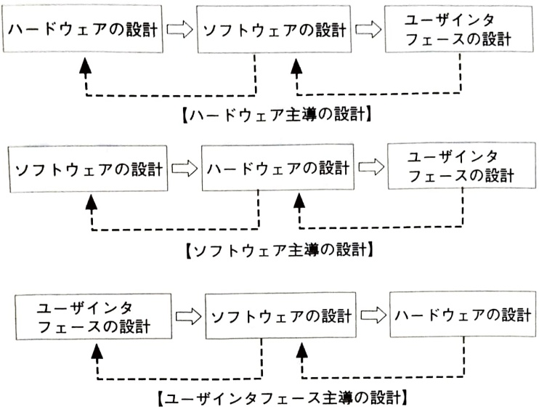
Figure 5.3.7 User-product interface framework
software, then hardware.
The concept and approach of interface design have a major impact on human reliability and safety, such as fail-safe design that prevents the chain of failures caused by hardware from spreading to users, and the structure and layout that prevents the functions of safety devices from being disabled. Efforts are needed to create an interface that is easy to use, safe, and that can maintain safety even when used in a faulty state.

Chapter 6 Systematic perspective and way of thinking
Automobiles and televisions can be developed into brakes, display devices, etc., and these can be further broken down into component parts. A system is composed of multiple elements, each element has a function, and failure of an element has some impact on the system. Therefore, an approach is required to evaluate the functional relationships between the individual elements and the system as a whole and to optimally design the system.
The method of achieving the basic functions of a car, such as running, turning, and stopping, changes depending on the selection of technology, such as the use of fossil energy or electric energy. The method and flow of converting energy change depending on the technological method. Therefore, in design, in addition to functionality,
・Determine configuration such as components, interfaces, layout and structure
・Multi-faceted evaluation of available technology methods, taking into consideration reliability, cost, and infrastructure such as roads and software supply channels during the use stage.
• Management related to technical method bottlenecks and solution policies and possibilities.
A system-based perspective and way of thinking are important.

6.1 System design

(1) Ability to define and organize elements

1) Thought process in design
As described in detail in Chapter 17, design is an inverse problem analysis, and it is required to meet the requirements for production and use after the design drawings are issued. Figure 6.1.1 shows the flow of developing requirements into functions, studying methods, mechanisms, and structures to realize the developed functions, and integrating them into an overall structure. In the process of developing functions into elements and defining and integrating structural elements, the CAD, CAE, and DfX environments are prepared and the functions are developed with an eye toward functional integration. In addition, we will create a system to turn knowledge into wisdom by utilizing technical standards and failure case studies, and manage design work so that it progresses efficiently and effectively.
Let's categorize design into two types: work that is easy to see and work that is difficult to see. The flow of analyzing requirements and breaking them down into functional elements is centered on logical thinking, and the media used to express the results are mainly words and are difficult to see. Conversely, functional elements
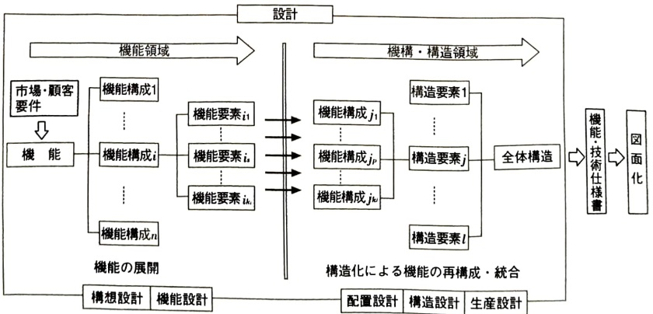
Figure 6.1.1 Reconfiguration by expanding and structuring functions
In the process of defining the mechanism and structural elements to be realized, the process and results can be expressed through diagrams, making it easy to visualize. If quality and cost issues are considered at the stage of development into functional elements and the time lag between problem formulation and discovery is shortened, the speed of resolution and improvements in both quality and cost will be significant.
Furthermore, the details of the function development will vary depending on the technical method. Selection of a technical method is an important decision, and it has a large impact on structuring and layout. The development and structure of higher-level functions to lower-level functions differs depending on the technology method, and it also affects the form of occurrence of quality problems such as failures during use, the effects of chain events, and the quality and cost of processing and assembly.
System design is a concept that recognizes a design solution as a whole in a ``functional framework'' rather than thinking in terms of time flow, and achieves design goals by satisfying constraints. It can be expressed in a hierarchical manner as shown in Figure 6.1.2, consisting of conceptual design, which focuses on the selection of technical methods to realize a function, and detailed design, which focuses on the definition of design variables such as structure and shape.
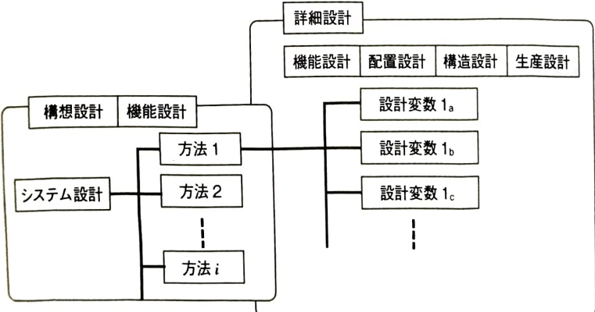
Figure 6.1.2 Hierarchical structure of system design

2) System engineering approach
Design work that develops requirements into functional elements and defines and integrates structural elements is a systems engineering approach. A systems engineering approach is a thought process that leads to the optimal plan to achieve a goal using the following steps.

① Clarification of purpose
Clearly define constraints, customer requirements, and cost goals. Translate customer requirements into functional terms and proceed with functional variations based on knowledge of technical methods. If there is insufficient functional variation, necessary functions may be overlooked during the detailed design stage of the part, resulting in drawings that are unclear. In particular, with regard to protective functions, check whether stress from the outside world is conservatively considered. In addition to influencing the margin for common cause failures, stress also changes depending on the layout, so it is closely related to layout design.

②Alternative plan
Consider and compare multiple options to achieve the objective. The prerequisite for optimization is to examine and confirm the existence of reasonable alternative designs. We will study principles, methods, structures, shapes, and materials while trying to harmonize with elemental technology development. We will promote the integration of new product development and technology development, such as providing feedback to technology development if it cannot be achieved with current domestic or foreign technology.


③ Modeling and simulation
Building a safety and reliability evaluation model with high detection power is important for evaluation and optimization. The key to modeling is to clarify the purpose of the evaluation and to ``build a simple model that is not too simple.''

④ Evaluation
Understand the margin against the limit, compare and consider alternatives, and use this to determine the optimal plan.
Ru. In addition to ``fulfilling the intended function,'' evaluate the disadvantages of ``unintended negative functions.'' The evaluation of disadvantages also covers problems that occur in conjunction with the external environment.評価のフレームワークの検討では，システム内部に加えて外部の使用環境条件，インフラストラクチャ等についても評価の範囲に含めて行う． We hope to attract the attention of experts in diverse fields such as machinery, electricity, materials, and services.

⑤ Optimization
Decide the objective quantitatively and select the optimal one from among the alternatives. When performing optimization, clarify the scope and background taken into consideration, such as usage conditions. This will be important in the management of changes and changes that will be required later.

⑥ Decision making
Compare the merits and demerits rather than whether it is possible or not, and select the optimal plan from among the alternatives as the design solution. The background and rationale will be provided not only for the adopted proposals, but also for other proposals that were not adopted. In particular, proposals that cannot be adopted at this time will be fed back to technology development issues in order to harmonize with product development.

⑦ Overall evaluation
If a defect is discovered after design, we will promptly provide feedback and make corrections. The accumulation and transmission of information on testing, inspection, operation, operation, and use are important as a foundation.

(2) Product life cycle orientation

1) Product life cycle approach
It is an empirical fact that ``70 to 80% of quality and cost are determined by the design at the development stage.'' At the development stage, we look at the future from production, use to disposal, and proceed with design by considering it from multiple perspectives from a bird's-eye view.
This phrase also suggests the importance of management. Marketing, product development. Even if we do our best by gathering knowledge and wisdom from each field, such as design technology and production technology, we may end up in an undesirable situation. Integration of various knowledge may not go well due to conflict-solving styles, delays in sharing information, etc. Clarify the scheme and basic policy that will serve as a framework for sharing objectives and goals and carrying out integration.
When it comes to the quality and cost of new products,
・Point of contact with customers during use
·Extent of commonality with other products
・Integration of test items and sharing of test equipment
• Utilization of existing production facilities and need for new investment
·Easy to mix production with other products
・Loading efficiency into shipping containers
・Consideration of serviceability such as maintenance
・Consideration for the environment
We will proceed with the study from a product life cycle perspective. To clarify the cost structure from development to disposal, consider everything from concept to production, use, and disposal. We will innovate the development process and improve coordination between departments and individual motivation. Front-loading is used to share and share the knowledge and information of post-processes that become clear as the design becomes concrete from the early stages of development. In addition, consideration for easy-to-manufacture designs, such as one-way assembly, contributes to improved quality and productivity in production.

2) Front loading and DfX
Figure 6.1.3 shows the relationship between life cycle considerations such as element development, processing/assembly, and use in the design process and these methods. At the stage when the design, such as layout and structure, becomes concrete, consideration must be given to production such as processing and assembly, which may lead to conflicts with constraints from usage environmental conditions. Front-loaded DfX “X”
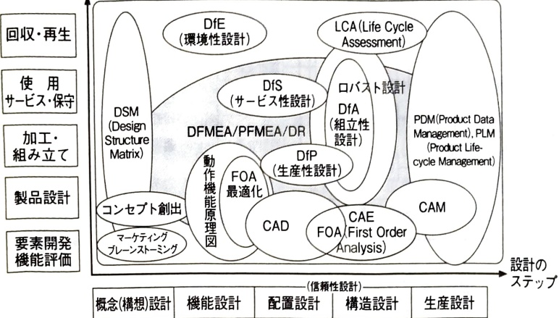
Figure 6.1.3 Relationship between product life cycle approach and design tools/methods
(Source) Hiroshi Otomi (2005): ``The importance of upstream design in product development and its method'', Toshiba Review, Vol. 60, No. 1, p. 34, with some modifications.
This requires leadership and management to work together to verify the design, production, and service departments, and to identify key points and optimize product and process design.

3) Impact on optimization of range of interest
Let's consider the product life cycle considerations when designing DVD players. The inside of the DVD player is the main board. A loader that inserts and removes discs and reads optical signals. It consists of a board for power control. The design philosophy of the main board differs depending on the approach to multilayer structure. The size of Company F's main board is a (cm) x b (cm), which is half of Company I's. This is because Company I's board has a two-layer structure, while Company F's has a four-layer structure. On the other hand, 4 layers increases the degree of semiconductor integration. The price per area will be higher. Company F's board is smaller, so it has a high degree of freedom in layout. Can be used in common with small models and DVD and VTR composite devices.
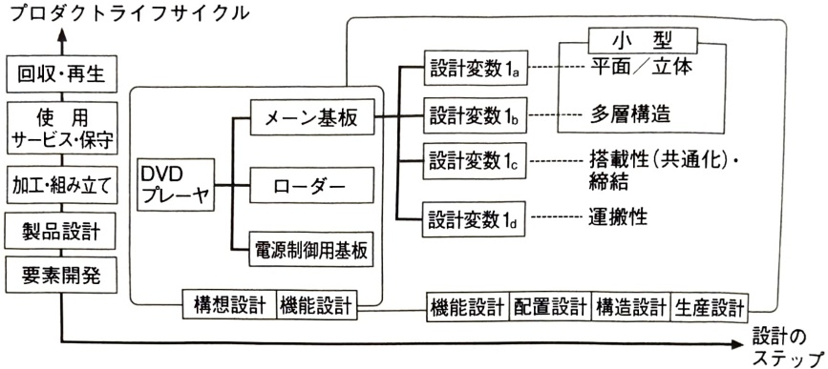
Figure 6.1.4 Example of design that takes product life cycle into consideration
It is designed to be able to The entire product is also smaller, and the depth is approximately $ d(\text{cm}) $ shorter than that of Company I. The number of vehicles that can be loaded into one shipping container increases, leading to a reduction in transportation costs of yen per vehicle. Company F's sales of DVD-related products in fiscal year 200x exceeded 2 million units, including overseas, and the cost reduction effect is significant. The company's approach to cost management is also reflected in the difference in profitability, with comments such as, ``Small and few parts lead to improved productivity.The idea behind this is that ``small is big,'' rather than simply choosing cheaper parts, and ``Based on our experience with VTRs, we consider everything from procurement to production to logistics to reduce costs down to the penny.''
Figure 6.1.4 shows how to proceed with system design by incorporating product life cycle-oriented thinking.

6.2 System reliability

(1) Reliability model and reliability allocation/prediction
The features of the system are:
・Systems and components have functions
・System functions work to adapt to the purpose
・The system has multiple functions and components
・Individual functions and components of a system are interrelated and influence other elements
That is what it means. When a system has many functions and components, similar elements are grouped together and expressed in a hierarchical structure.
For a system composed of multiple mutually independent elements, we consider the quantitative relationship between the reliability of the elements and the system. Quantitative relationships can be used for reliability allocation, which develops each configuration based on the reliability target, and for reliability prediction, which predicts system reliability from the evaluation results of each component.

1) System reliability modeling and reliability distribution/prediction
If the $n$ elements making up the system are independent from each other, the system reliability $R$ is a function of the reliability $R_i$ of element $i (=1, 2, \cdots, n)$, as follows:
$$ R=f\left(R_{1},R_{2},\cdots,R_{n}\right) $$
It can be expressed as
Using the relationship in equation (6.2.1), we perform system reliability allocation and prediction. Reliability allocation is done by assigning trust to each component shown in Figure 6.2.1 in order to achieve the goal of system reliability.
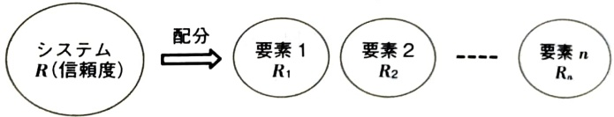
Figure 6.2.1 Reliability allocation approach
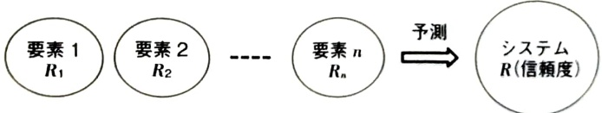
Figure 6.2.2 Reliability prediction approach
This is an approach that develops and allocates degree-day markers. Reliability prediction is an approach shown in 6.2.2 that predicts the reliability of the system based on the experimental values ​​of each component and reveals whether or not the Japanese standard will be achieved.

2) Some examples of redundant systems
The reliability of the power distribution system that transmits power from power plants to consumers is important as a part of social infrastructure, so systems are constructed in such a way that even if one part of the distribution system fails, the impact does not spread to the entire system. This kind of system configuration is called redundancy, and typical redundancy is
・Power supply using spot network method (2/3 redundant system)
・Power supply using π loop method (standby redundancy system)

There is.
The power supply system using the spot network method (2/3 redundant system) is shown in Figure 6.2.3. It is applied to high-density, large-capacity loads such as high-rise buildings in urban areas. Power is received through two or more primary distribution lines (usually three lines), and the secondary side of the transformer installed for each line is shared, so even if some primary distribution lines or transformers are stopped, power can be received without interruption. This is an extremely reliable supply method. When a substation circuit breaker opens due to an accident on a power distribution line, current flows backward from the low voltage side to the primary side of the transformer, and the network protector is activated. In this case, since the low-cost system supplied from this system will be supplied through other healthy primary distribution lines and network transformers connected thereto, no supply problems will occur.
Figure 6.2.4 shows a power supply system using the π-loop method (standby redundant system). It is used in a system that connects a primary substation that relays power sent from a power plant to a secondary substation that relays it further. Compared to secondary substation A, secondary substation B opens disconnector ② and closes ① to allow power to be transmitted from the secondary substation when it is no longer possible to directly transmit power from the primary substation. This increases the reliability of the power supply from secondary substation B.

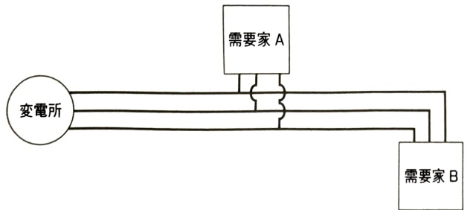
Figure 6.2.3 Power supply using spot network method (2/3 redundant system)
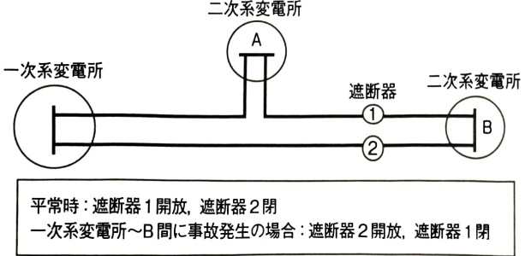
Figure 6.2.4 Power supply using π loop method (standby redundant system)

(2) Reliability of serial and redundant systems
Specific representations of general systems will be discussed in Section 6.3, but here we will discuss the reliability of series and parallel systems. In other words, systems can be divided into two categories depending on whether they are serial or not, as shown in Figure 6.2.5, and redundant systems that are not serial can be further classified into parallel systems, etc.

1) Reliability of series system
In a series system, as shown in Figure 6.2.6, if one of the components fails, the system will fail. Therefore, the relationship between series system and component life is
$$ T=\min\left(T_{1},T_{2},\cdots,T_{i},\cdots,T_{n}\right) $$
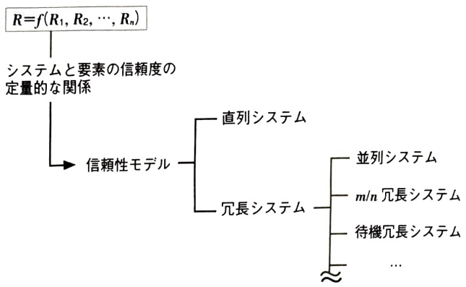
Figure 6.2.5 Classification of reliability models using dichotomy
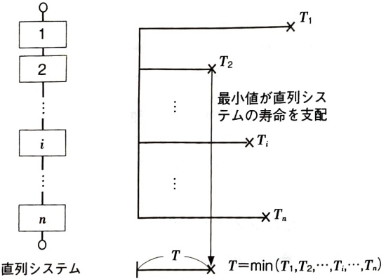
Figure 6.2.6 Relationship between series system and element life

becomes.
From equation (6.2.2), the relationship between the reliability of the series system $ R $ and the reliability of the components $ (R_i, i=1,\cdots,n) $ is that the system is functional only when all the components are functioning, so if the failures of the components are independent of each other.
$$ R=R_{1}\times R_{2}\times\cdots\times R_{n} $$
The relationship holds true. Regarding the failure rate λ of the series system and the failure rate of the components (λᵢ, i=1, …, n). A failure of any component results in a failure of the system.
$$ \lambda=\lambda_{1}+\lambda_{2}+\cdots+\lambda_{n} $$
becomes.

2) Reliability of parallel systems
As shown in Figure 6.2.7, in a parallel system, if all the components fail, the system will fail. Therefore, the relationship between the parallel system and the lifespan of the components is as follows.
$$ T=\max\left(T_{1},T_{2},\cdots,T_{i},\cdots,T_{n}\right) $$
becomes.
From equation (6.2.6), the relationship between the unreliability and reliability of the parallel system and the components is as follows, if the failures of each component are independent of each other:
$$ \begin{aligned}F&=F_{1}\times F_{2}\times\cdots\times F_{n}\\&=\left(1-R_{1}\right)\times\left(1-R_{2}\right)\times\cdots\times\left(1-R_{n}\right)\end{aligned} $$
$$ \begin{aligned}R&=1-F\\&=1-\left[\left(1-R_{1}\right)\times\left(1-R_{2}\right)\times\cdots\times\left(1-R_{n}\right)\right]\end{aligned} $$
becomes. Here. $F$ and $R$ are the unreliability and reliability of the parallel system, respectively.
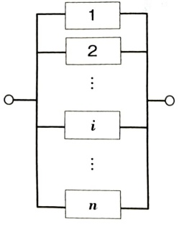
parallel system
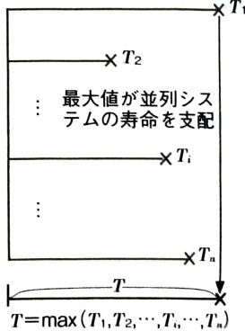
Figure 6.2.7 Relationship between parallel system and element life

3) Application of properties of series and parallel systems to design
Characteristics of reliability of series systems According to equation (6.2.3), when the number of components $n$ is increased,
$$ R=R_{1}\times R_{2}\times\cdots\times R_{n}\xrightarrow{n\rightarrow\infty}0 $$
becomes. To make the system highly reliable, it is necessary to reduce the number of components $n$. "Simplification" is the principle of reliable design.
In a parallel system, increasing the number of components n gives
$$ F=F_{1}\times F_{2}\times\cdots\times F_{n}\xrightarrow{n\rightarrow\infty}0 $$
As for the reliability,
$$ R=1-F\xrightarrow{n\rightarrow\infty}1 $$
It is. Therefore, increasing the redundancy will bring the reliability closer to 1. However, it is assumed that the failures of each component are independent of each other, and it is important when designing a parallel system to consider the layout so that failures do not occur simultaneously due to a common cause.

6.3 Coherent systems

(1) Generalization of system concepts
We will consider the reliability and characteristics of systems that are more generalized series and parallel systems.The concepts of system structure functions and coherence will be important.

1) Structure function
Consider a system consisting of n elements, and assume that the state of each element is either working or faulty. The state of each element is expressed as a binary variable $ x_i (i = 1, \cdots, n) $,

$$ x_{i}=\left\{\begin{aligned}1,& when element i is working \\ 0,& when element i is broken \end{aligned}\right. $$
It is expressed by Similarly, assuming that the state of the system is either working or failing, the binary variable φ,
$$ \phi=\left\{\begin{aligned}1,& When the system is working \\ 0,& When the system is broken \end{aligned}\right. $$
correspond.
At this time. Assuming that the state of the system is determined by the state of the elements. The state of the system is given by the vector $\mathbf{x}=(x_{1},\cdots,x_{n})$ that represents the states of n elements.
$$ \phi=\phi\left(\mathbf{x}\right) $$
It can be written as In general, the state of the system cannot be revealed only from the states of its elements, so φ ≠ φ(x).
The basic system structure function is as follows.

① Series system
Since the system functions only when all the elements that make up the system function, the structure function φ(x) is
$$ \phi\left(\mathbf{x}\right)=\prod_{i=1}^{n}x_{i}=\min\left(x_{1},\cdots,x_{n}\right) $$
becomes.

② Parallel system
Since the system is faulty only when all elements are faulty, the structure function $ \phi\left(\mathbf{x}\right) $ is
$$ \phi\left(\mathbf{x}\right)=\coprod_{i=1}^{n}x_{i}=1-\prod_{i=1}^{n}\left(1-x_{i}\right)=\max\left(x_{1},\cdots,x_{n}\right) $$
becomes.
③ k/n redundant system
The system functions as long as at least k elements out of n are functioning, so the structure function $ \phi(\mathbf{x}) $ is

